PYTHON ESSENTIALS

In this lecture, we will cover some patterns and techniques that are quite useful when building and testing python based scripts and applications.

**Introduction** **2**

Installing Packages 2

Running Python 2

REPL.it 2

Google Colab 12

Docker 25

Docker Compose and Jupyter Notebook 28

**Generators** **31**

**Concurrency** **41**

# 

# 

# 

# 

# 

# 

# 

# 

# 

### **Docker**

Arguably the best approach of all three is to leverage Docker to write, test and run python code. For the rest of this document, we will be leveraging Docker specific techniques as we write and run code in python.

The simplest approach to running some python code in docker is as follows:

docker run -it python:3.7 python

In screenshots:

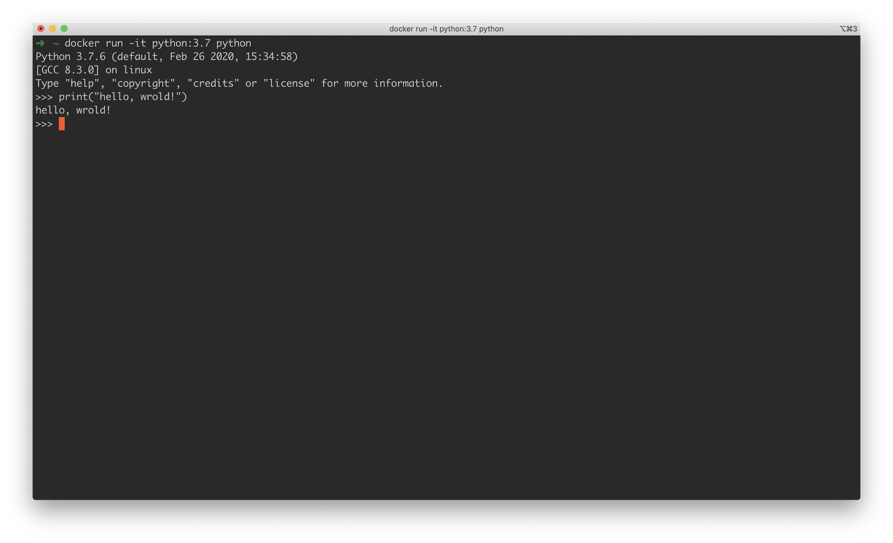

This will start a docker container and run the python REPL in-terminal. This is a nice and quick way to test stuff while developing python scripts in terminal. However, if we need to leverage further complexities, like custom packages from PyPI, we need to create a Dockerfile:

|  |
| --- |
| **FROM** python:3.7 # specify docker image  **WORKDIR** /app # set folder inside container  COPY requirements.txt /app # copy requirements to container  RUN pip install -r requirements.txt # install packages |

And we will need a requirements.txt:

|  |
| --- |
| requests==2.23.0 |

To run, same as before:

docker run -it python:3.7 python

But now all dependencies will be *installed* for us - which means we can import and access as needed.

Now, if we **git clone** the [**repo**](https://github.com/mottaquikarim/STA9760_github_client)and copy our Dockerfile into the same folder, we can run our github client code via docker in terminal.

First, move everything to the right place, like so:

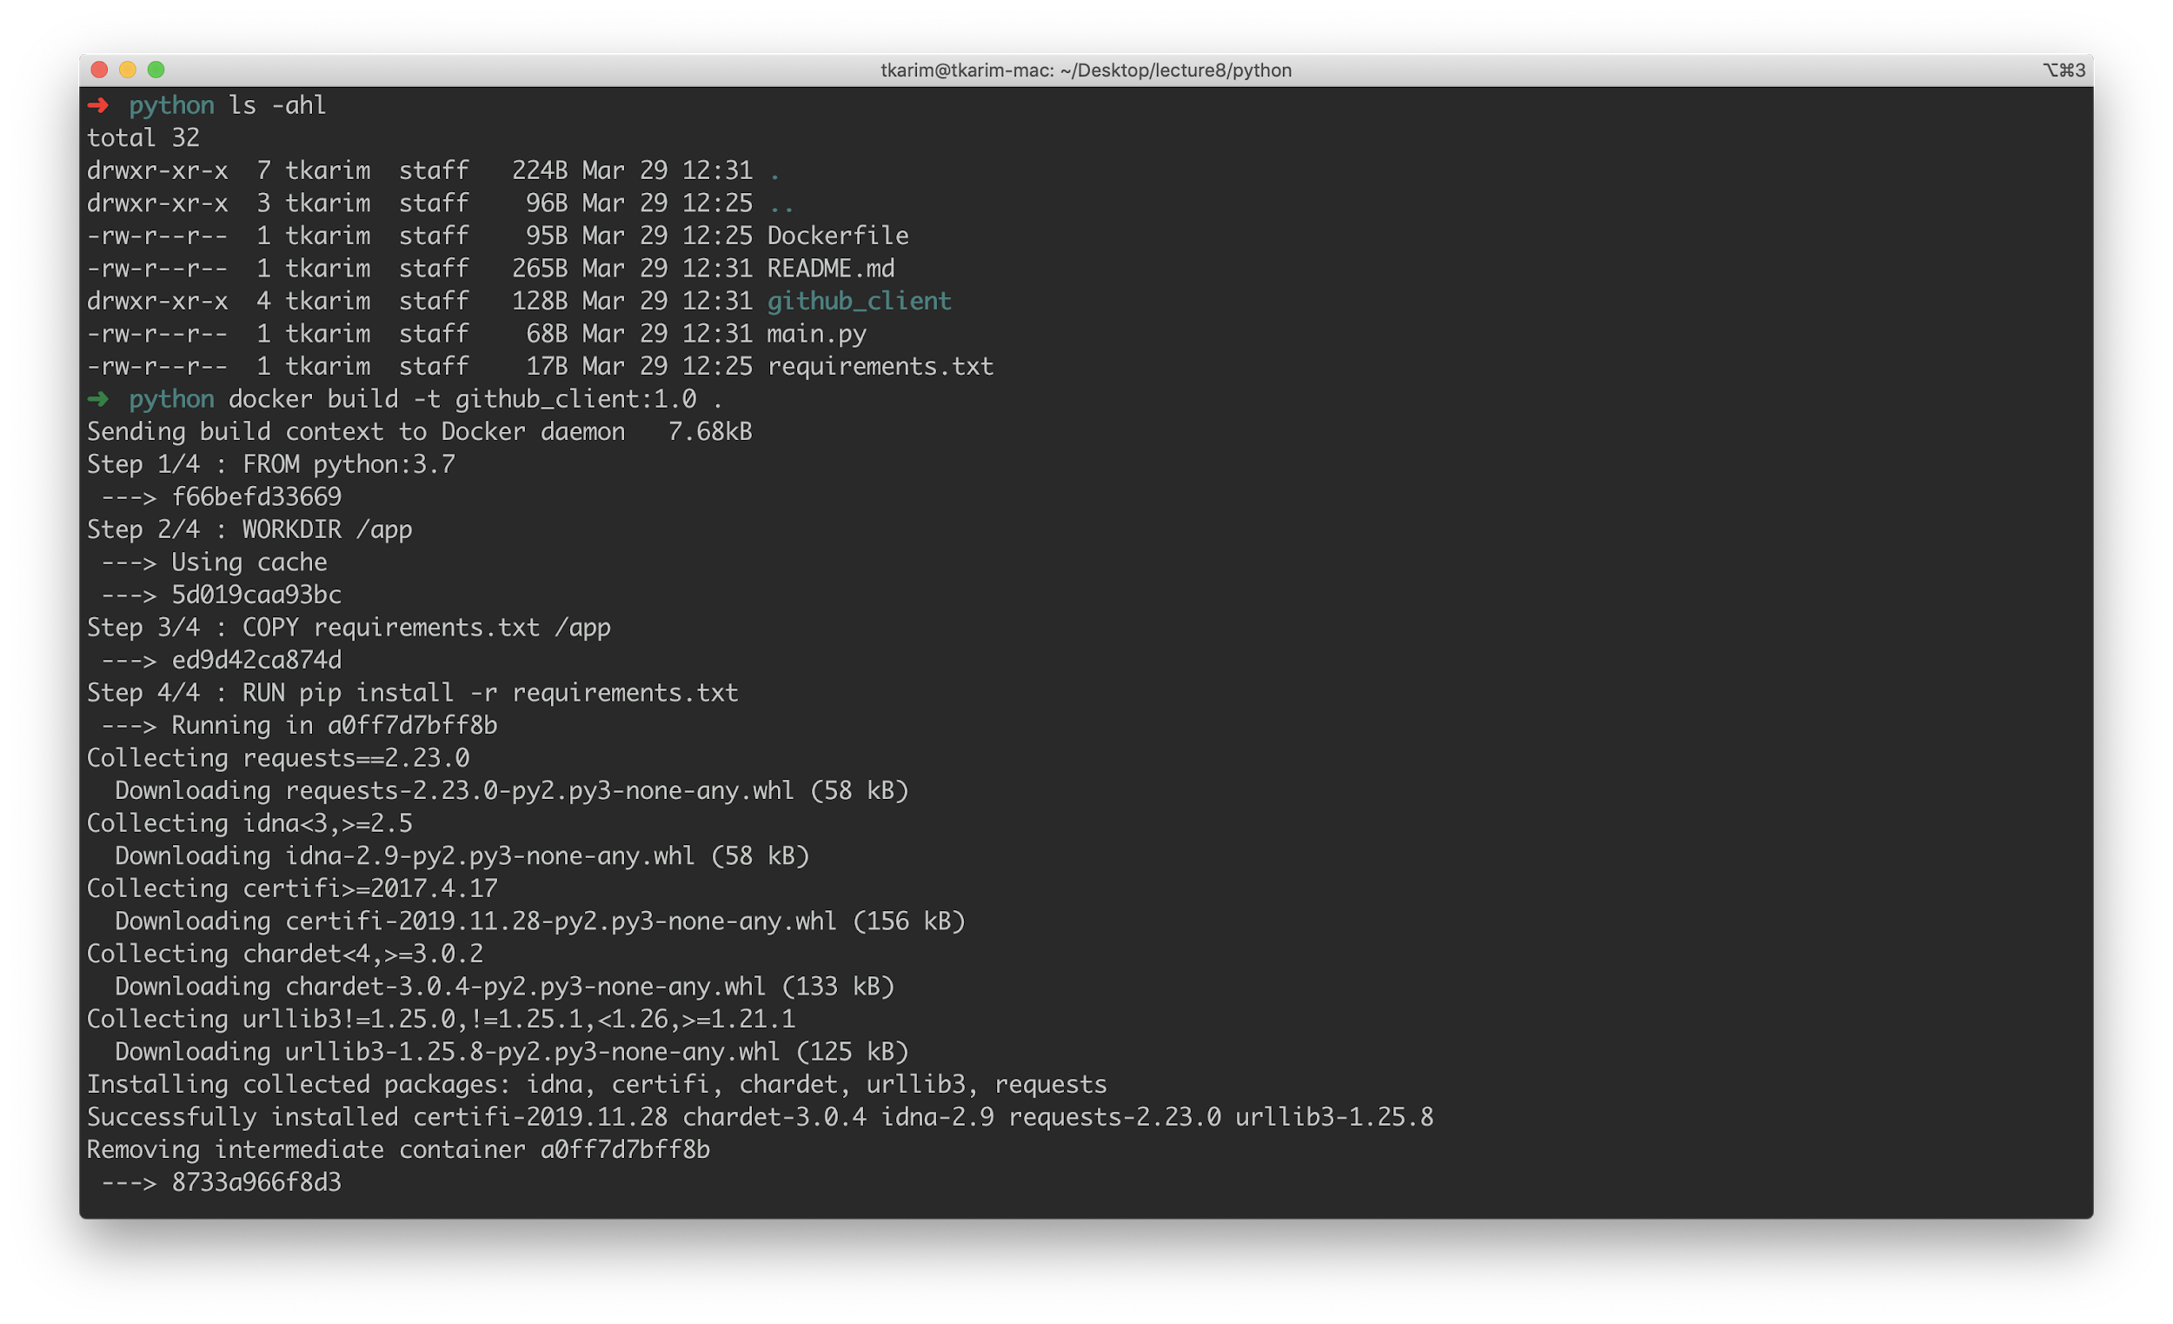

The main differences here are that we now have a Dockerfile and a requirements.txt in this repo along with the files we developed in REPL. Using this dockerfile and requirements.txt, we can run the following:

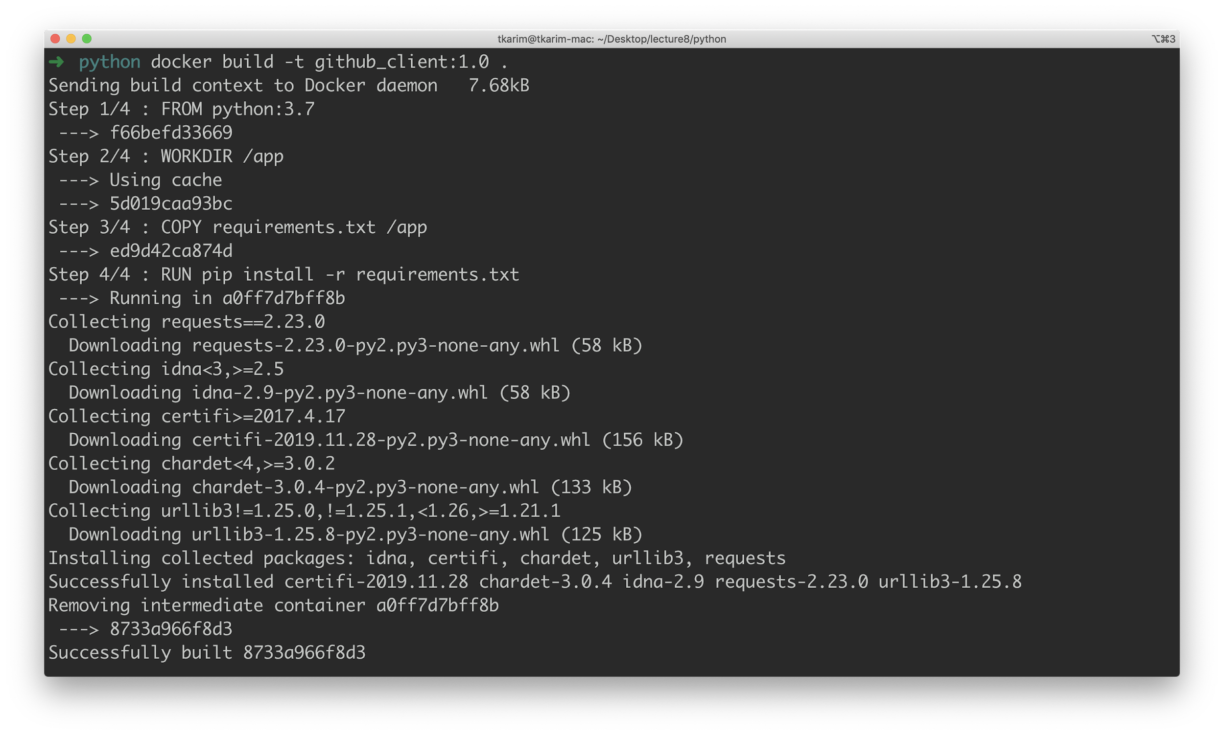

**docker build -t github_client:1.0 .**

This will build a new image for us that contains our requirements.txt. To run our **main** python file with this image, we:

**docker run -v $(pwd):/app -it github_client:1.0 python main.py**

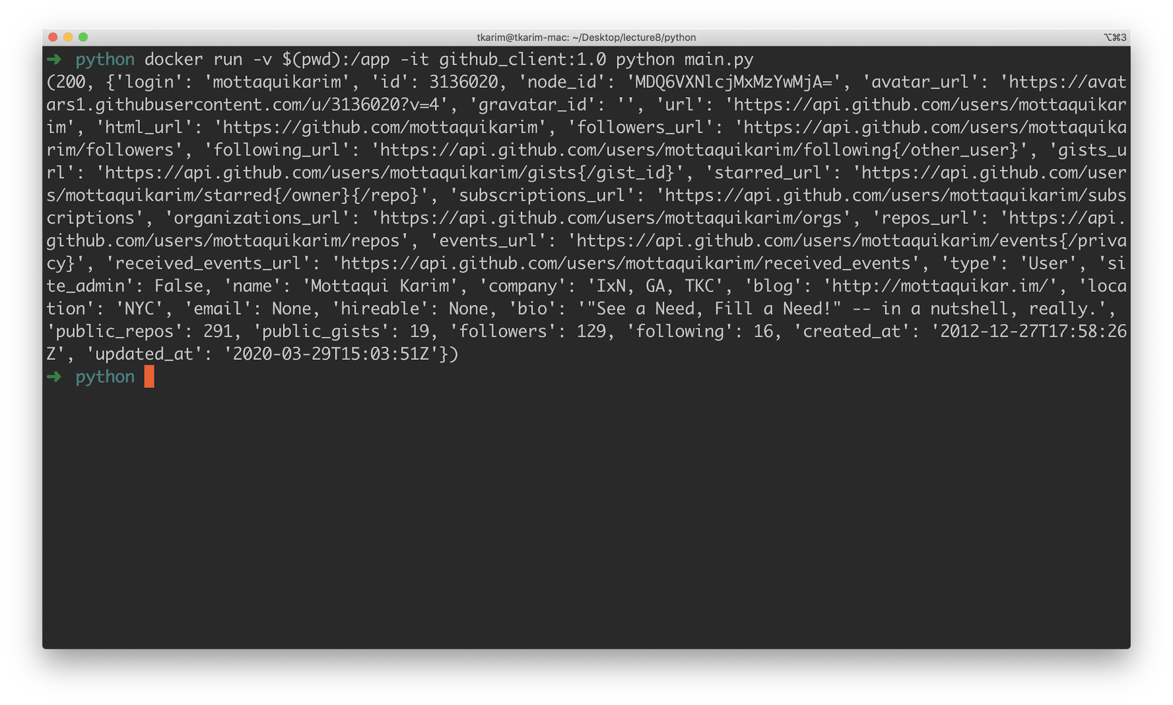

This is the simplest approach to getting a python project running with docker. If we wanted to be slightly more sophisticated, we can also specify a docker-compose file to make our life slightly simpler from the terminal:

|  |
| --- |
| version: '3' services:  github_client:  build:  context: .  volumes:  - .:/app:rw |

This is the **docker-compose.yml** file needed to define our service in docker-compose. Using this file, we can simply run:

**docker-compose run github_client python main.py**

Which eliminates the need to specify a `-v`, etc, making the actual call simpler. If we wanted, we could also add the **entrypoint** property to make this even simpler:

|  |
| --- |
| version: '3' services:  github_client:  build:  context: .  entrypoint: ['python', 'main.py'] # this is the change  volumes:  - .:/app:rw |

With entrypoint specified, we can simply run:

**docker-compose up**

And it is enough to run the container *and* our main file:

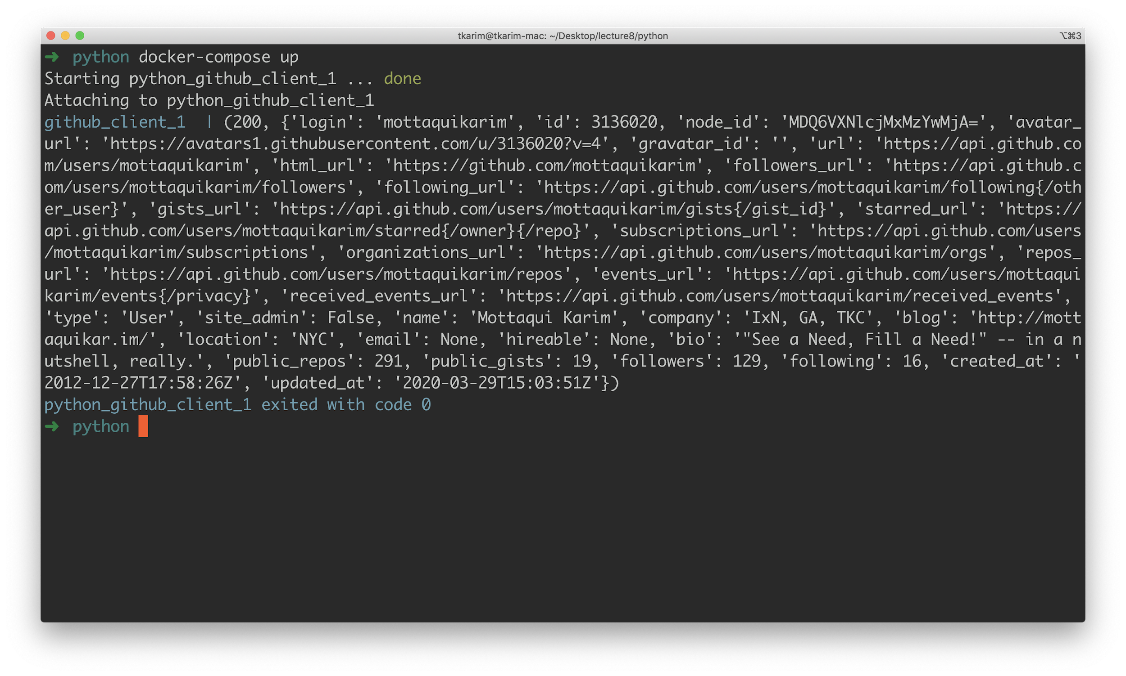

### **Docker Compose and Jupyter Notebook**

One final note: leveraging docker compose, we can stand up a Jupyter Notebook instance in an EC2 instance, thus allowing us to access our own jupyter notebook instance from anywhere, so long as we have access to the internet.

All that is needed is the following **docker-compose** file:

|  |
| --- |
| version: '3' services:  datascience-notebook:  image: jupyter/base-notebook:latest  volumes:  - /tmp/jupyter_test_dir:/home/docker_worker/work  ports:  - 8888:8888  command: "start-notebook.sh"  user: root  environment:  NB_USER: docker_worker  NB_UID: 1008  NB_GID: 1011  CHOWN_HOME: 'yes'  CHOWN_HOME_OPTS: -R |

And the follow **.env** file:

|  |
| --- |
| # Define a local data directory # Set permissions for the container: # sudo chown -R 1000 ${LOCAL_WORKING_DIR}  LOCAL_WORKING_DIR=/data/jupyter/notebooks  # Generate an access token like this # import IPython as IPython # hash = IPython.lib.passwd("S-E-C-R-E-T") # print(hash) # You can use the script generate_token.py  ACCESS_TOKEN=sha1:d4c78fe19cb5:0c8f830971d52da9d74b9985a8b87a2b80fc6e6a  # Host port PORT=8888  # Provide data sets LOCAL_DATASETS=/data/jupyter/datasets  # Provide local modules LOCAL_MODULES=/home/git/python_modules  # SSL # Generate cert like this: # openssl req -x509 -nodes -newkey rsa:2048 -keyout jupyter.pem -out jupyter.pem # Copy the jupyter.pem file into the location below. LOCAL_SSL_CERTS=/opt/ssl-certs/jupyter |

With this set up, on your local machine you can simply run:

**docker-compose up -d**

To start the service. For the first time you run jupyter notebook, you will need a special URL. To find this URL, run:

**docker-compose logs datascience-notebook**

This will open up docker logs for the container you just created and ran (NOTE: super useful when debugging docker containers in general), which should look something like this:

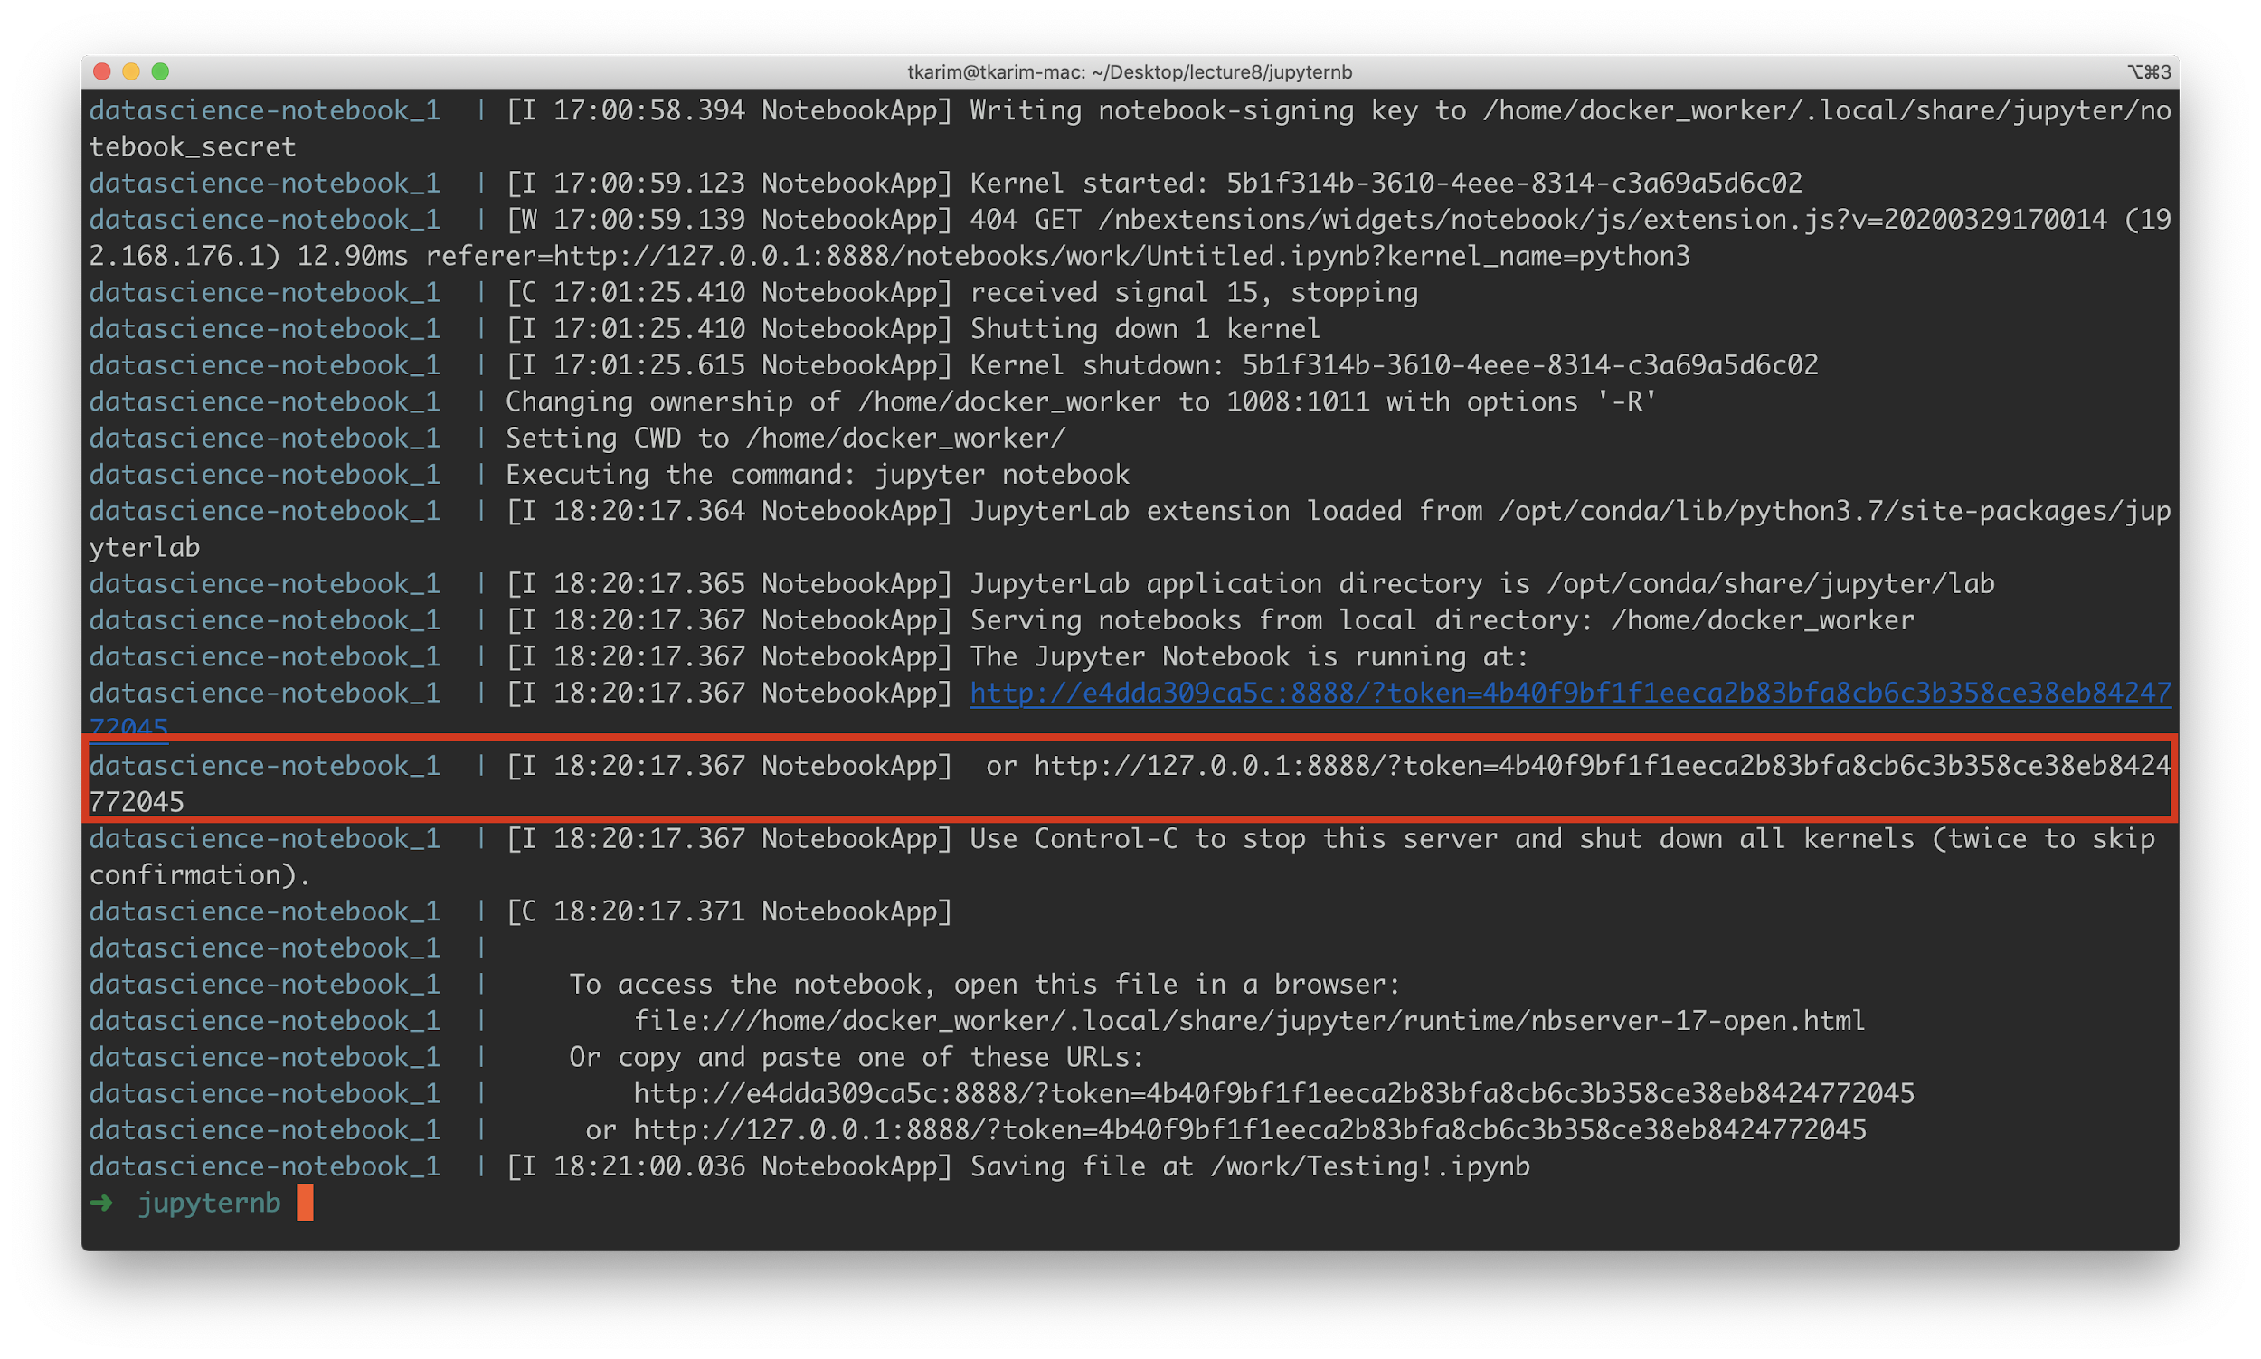

The URL above (might be different for you) is:

**http://127.0.0.1:8888/?token=4b40f9bf1f1eeca2b83bfa8cb6c3b358ce38eb8424772045**

Opening in browser results in:

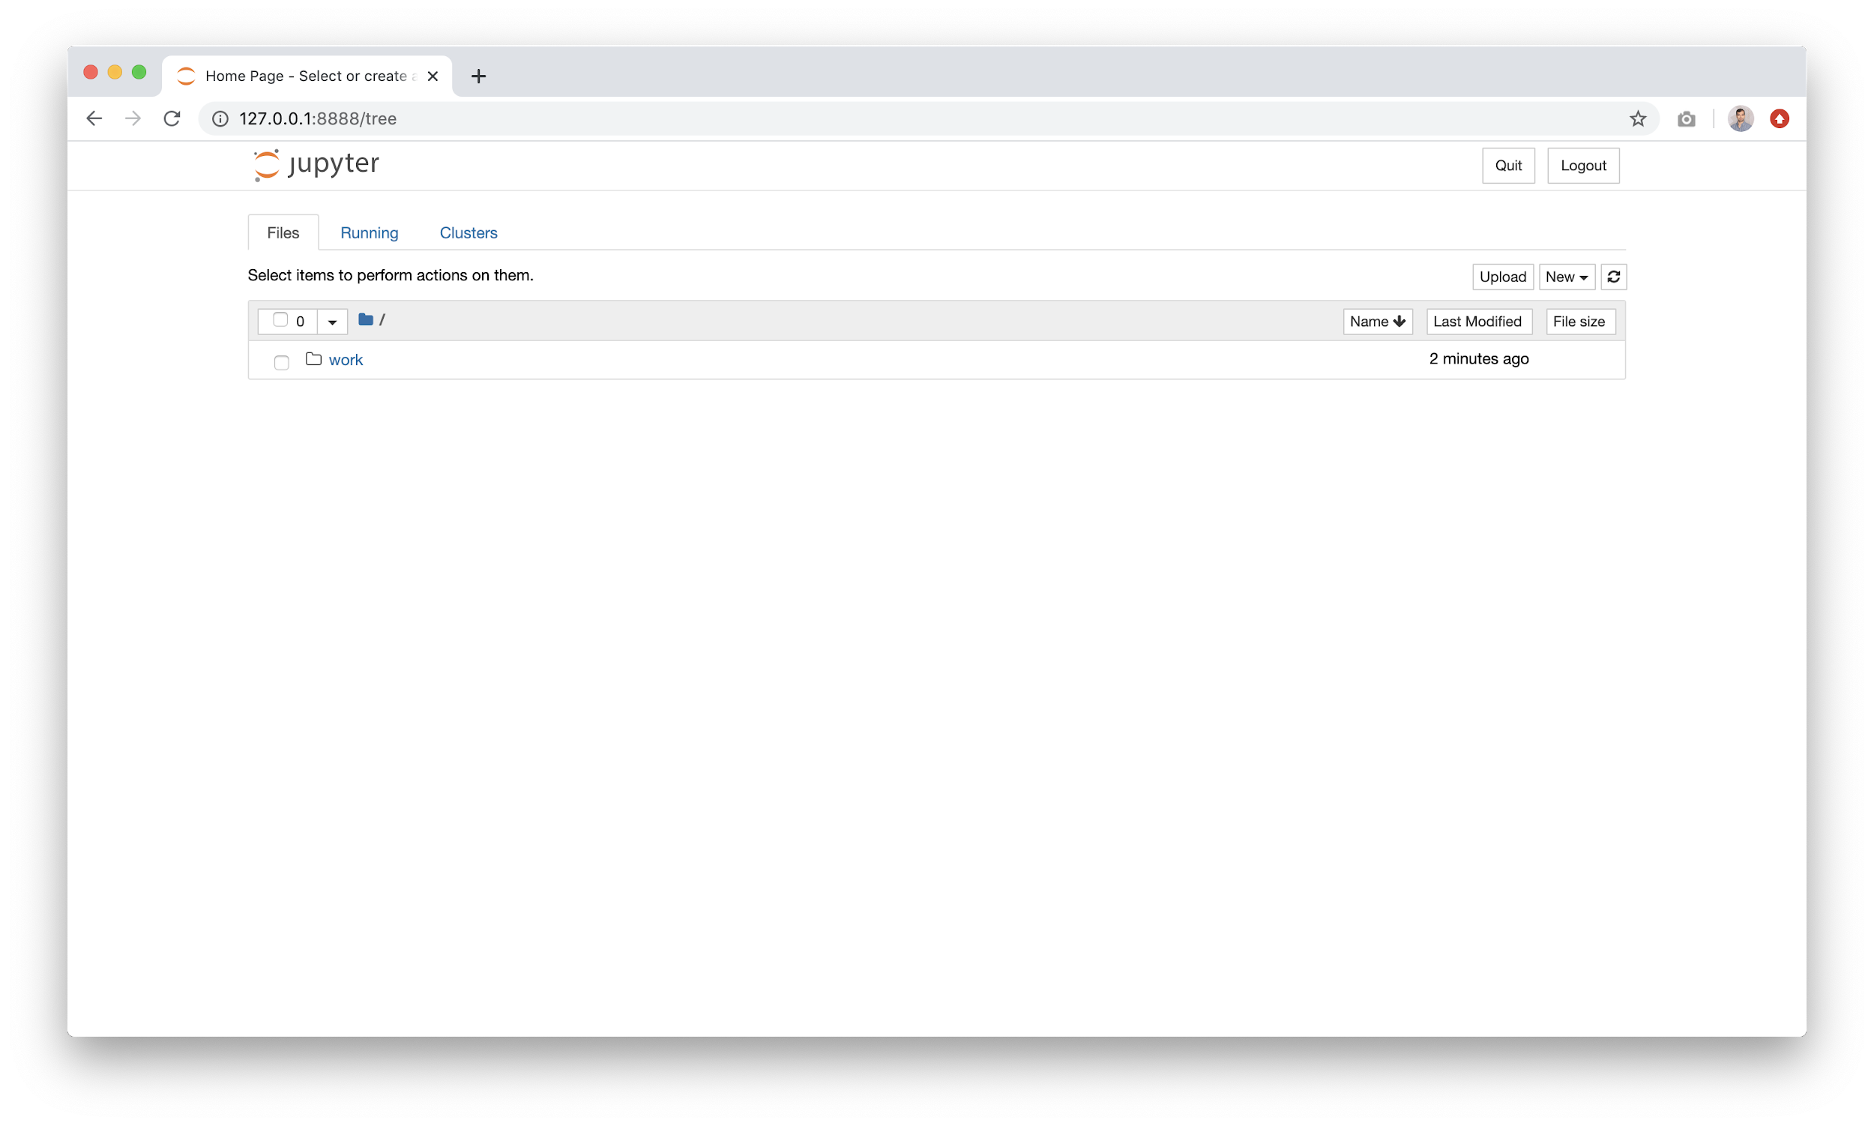

A working jupyter instance! Plus, files you save will automatically be recovered when you restart the docker container. Also, it is **secure** in that trying to open [**http://127.0.0.1:8888**](http://127.0.0.1:8888) in an incognito window will result in a password protected page. In other words, if this was launched in an EC2 instance, you’d have security baked in by default - allowing only you or members of your organization only to access the content.

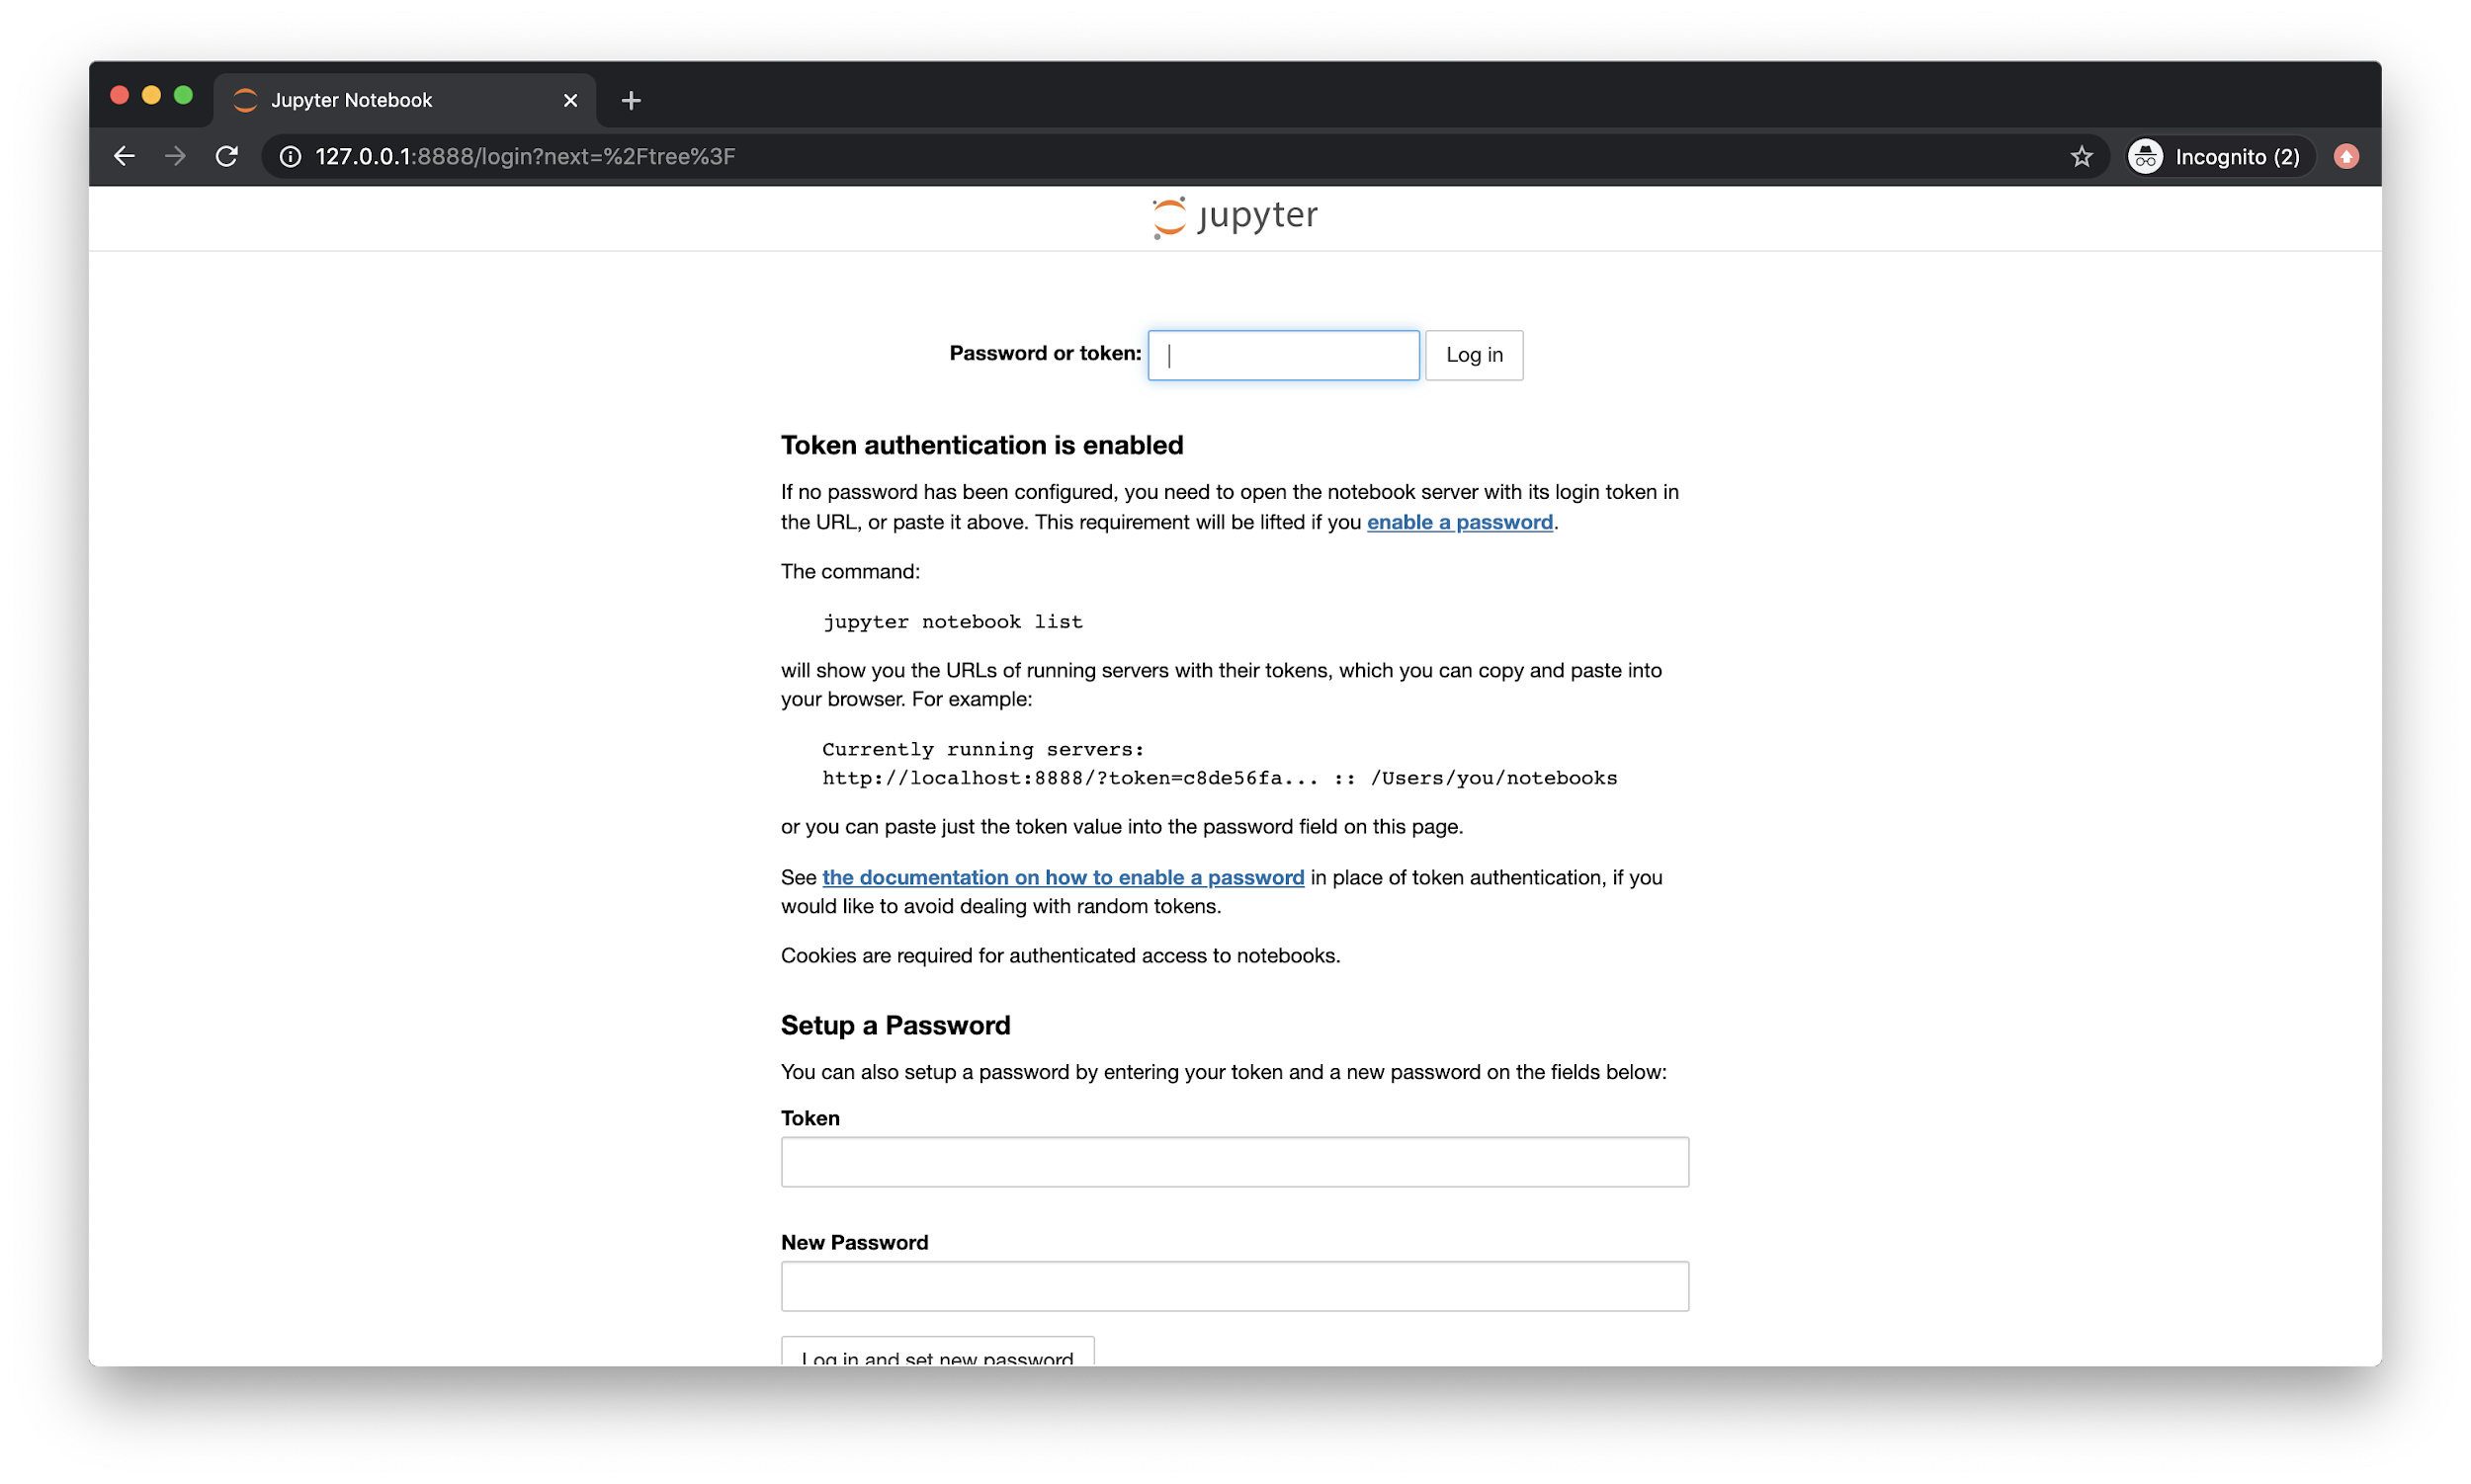

To launch in EC2, you will have to play around with security groups and VPCs. Here is a resource for setting up EC2 with the ability to access the [**internet**](https://dataschool.com/data-modeling-101/running-jupyter-notebook-on-an-ec2-server/) (here is another resource with very good [step by step instructions](https://docs.nginx.com/nginx/deployment-guides/amazon-web-services/ec2-instances-for-nginx/) for creating EC2 with internet access permissions). Once you set up EC2 with access to the internet, you can install [**docker**](https://www.digitalocean.com/community/tutorials/how-to-install-and-use-docker-on-ubuntu-18-04) and [**docker-compose**](https://www.digitalocean.com/community/tutorials/how-to-install-docker-compose-on-ubuntu-18-04). After installation, you simply need to copy the docker-compose provided here and run `docker-compose up -d` to get the container started. Then, visit your browser with the public IP of your EC2 instance to access Jupyter.

# Generators

Generators are often called “lazy iterators”. They represent a way to write and iterate large volumes of data without expending too much memory. As such, they are very very important in managing “data streaming” tasks where we flow large amounts of information through our code but process this information only “chunks” at a time, thereby allowing us to conserve resources and process the entire set of information without encountering memory overflows.

Let’s begin with a simple example:

|  |
| --- |
| **import** sys **from** time **import** time  numbers = range(10000000) # for loop as list comprehension s = time() squared_numbers = [n*n **for** n **in** numbers] sum_squares = sum(squared_numbers)  # for loop as "generator" comprehension s = time() squared_numbers_gen = (n*n **for** n **in** numbers) sum_squares_gen = sum(squared_numbers_gen) |

In this example, we have two ways to do the same computation - the first way is likely the more familiar approach, where we are simply iterating through a range of numbers from 0 - 9999999, squaring at each iteration. Then, we take that list and sum all the numbers in that list.

Before thinking about generators (the second example) let’s think about efficiency here for a minute. First, we are looping through a range and creating a new list that is the exact same size (10000000 items) but where each number is squared (meaning the “size” of this list is much larger than the original range). Then, we walk through this new list and add each item to a running sum, getting our solution.

The “inefficiency” here is that we have an intermediate value - the list of squared numbers that is of no use aside from that addition step.

Now, with that being said, let us consider the generator approach. In this approach, we are “lazily” evaluating, meaning that we only store the *current* number in our iteration (so 0, then 1, then 2, etc) in memory and at each iteration, we simply add to the running sum (maintained within the sum function). What this allows us to do is **obviate** the need for the intermediate list! We save a ton of memory as a result. Consider this slightly updated version of the script above, which prints execution time and memory usage as well:

|  |
| --- |
| **import** sys **from** time **import** time  numbers = range(10000000)  s = time() squared_numbers = [n*n **for** n **in** numbers] sum_squares = sum(squared_numbers) print('NORMAL ITERABLE') print(f""" sum | time | memory ------------------------------------------------------------------- {sum_squares} | {time()-s} | {sys.getsizeof(squared_numbers)} """)  s = time() squared_numbers_gen = (n*n **for** n **in** numbers) sum_squares_gen = sum(squared_numbers_gen) print('GENERATOR') print(f""" sum | time | memory ------------------------------------------------------------------- {sum_squares_gen} | {time()-s} | {sys.getsizeof(squared_numbers_gen)} """) |

The output for this, once run via docker:

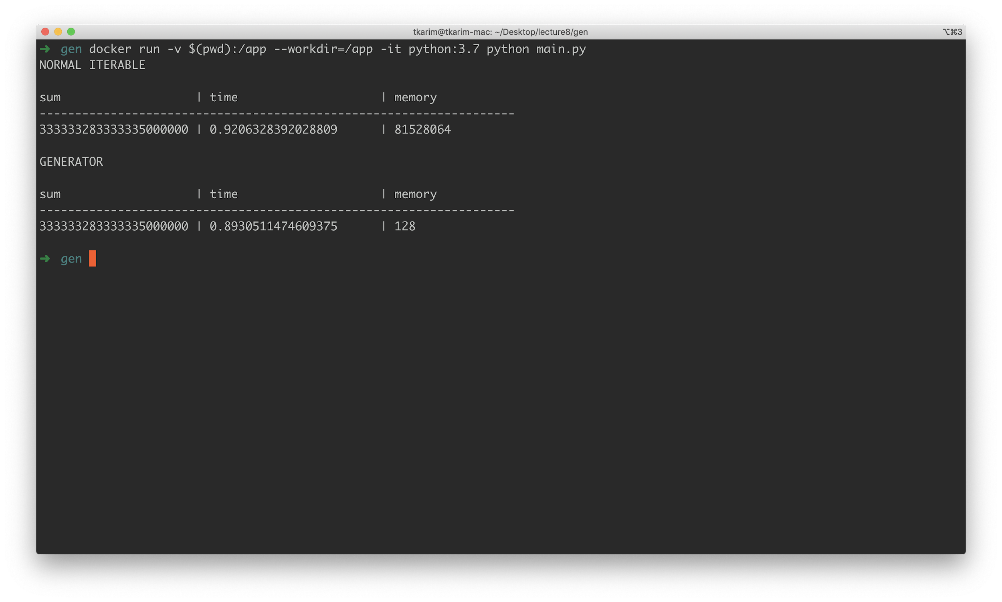

As you can see - the “normal” version is somewhat slower but **significantly** heavier, in that memory usage is several orders of magnitude higher. This is the beauty of generators.

Let’s put this principle to the test. First, we will generate or download a very large CSV file. For the purposes of this example, we will use a CSV file that is available from the course content google drive, **201709-citibike-tripdata.csv**.

This file is 336.4MB in size. Let’s try to read this file in, multiply it by 4 and then write it back somewhere. The naive approach to this would look something like this:

|  |
| --- |
| **if** __name__ == '__main__':  **with** open('201709-citibike-tripdata.csv', 'r') **as** fh:  lines = fh.read().split('\n') * 4  print(lines) |

IN this example, we are running a **file.read** operation, which loads the **entire** file into memory before acting on it. If you can imagine, this will not work. Trying to run this file via docker gives us:

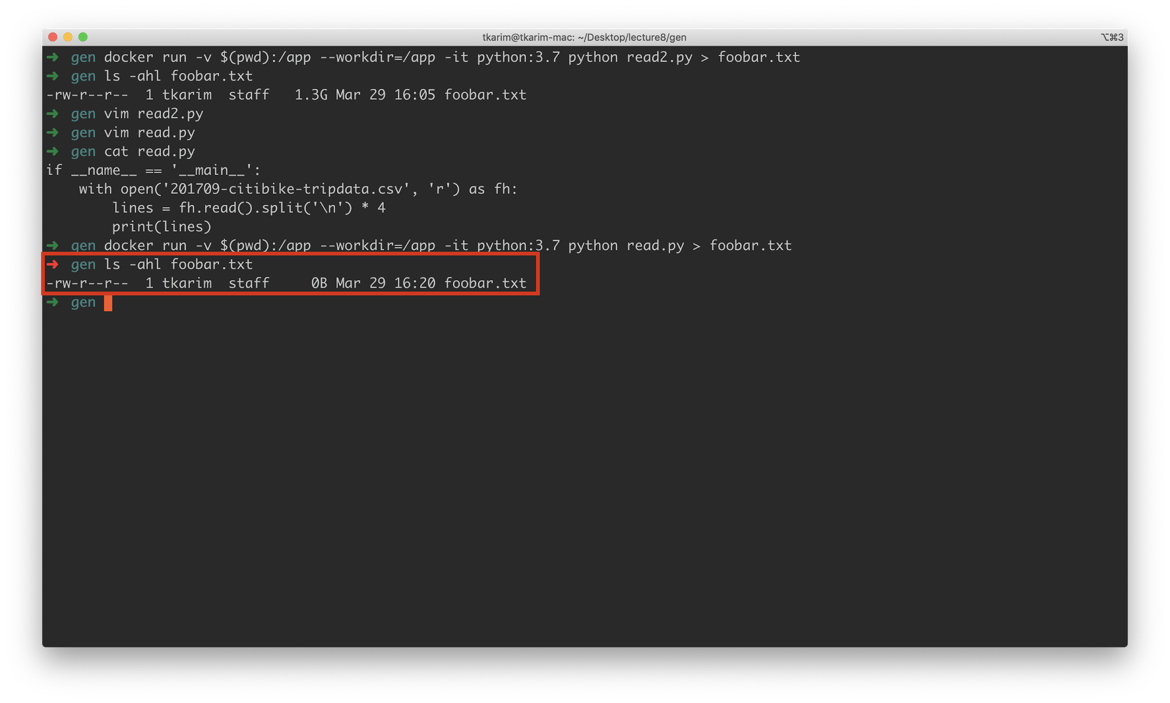

**Zero BYTES**. Why? Because docker ran out of memory and basically killed the task. This can be verified by running this from *inside*  the container:

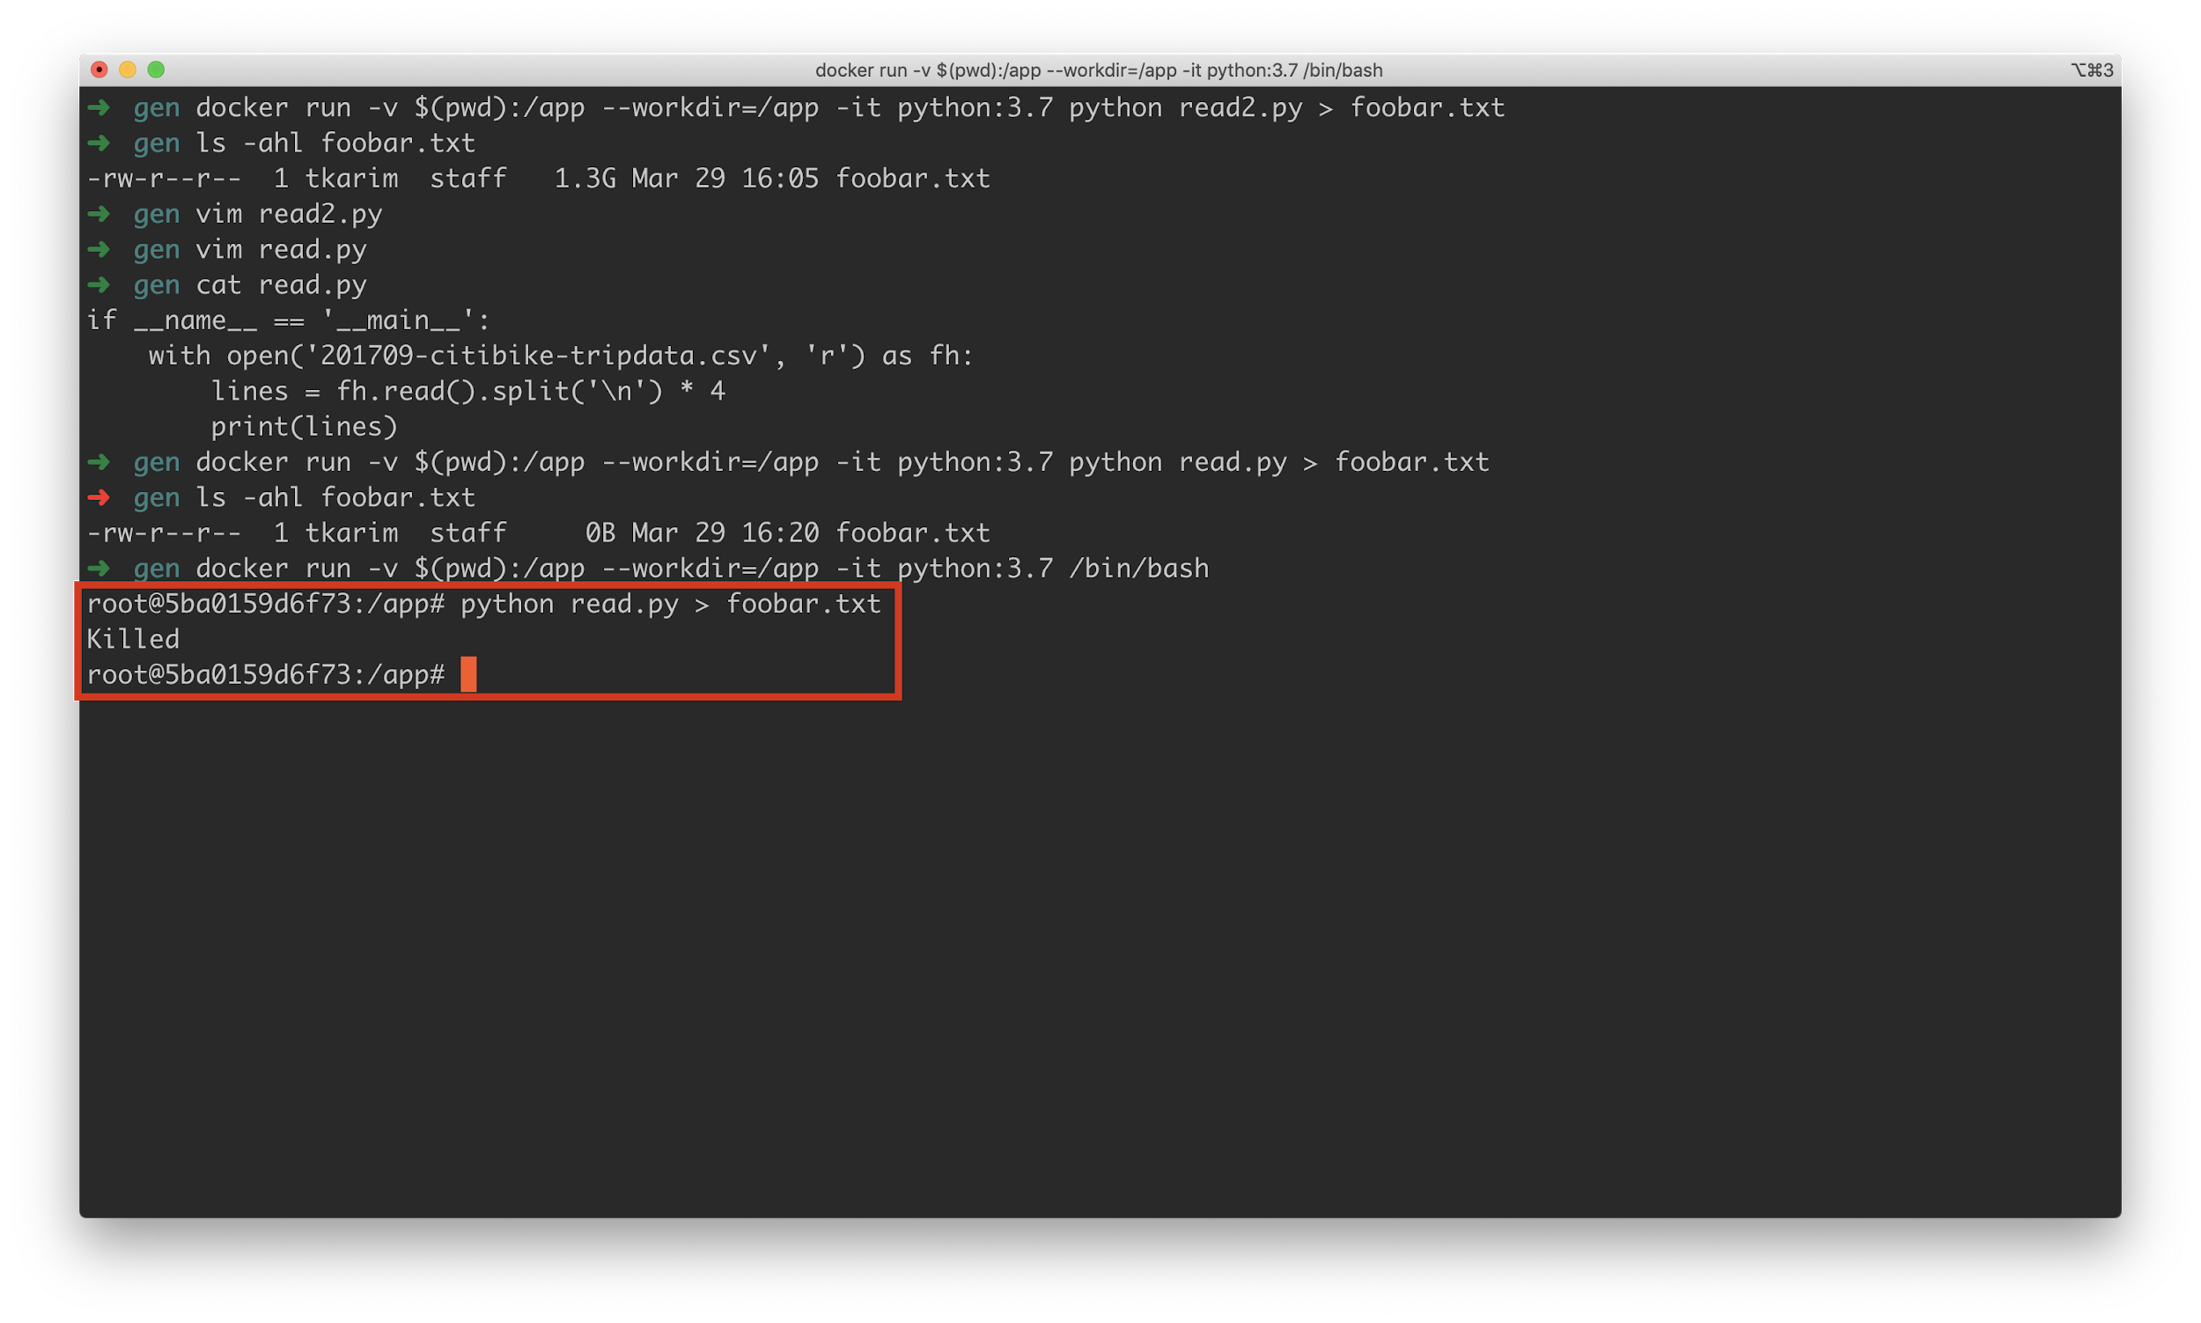

Basically, the application has run out of memory. But - this operation is possible! If we take advantage of the generator features of python. Let’s refactor our code, like so:

|  |
| --- |
| **if** __name__ == '__main__':  **with** open('201709-citibike-tripdata.csv', 'r') **as** fh:  **for** line **in** fh:  print(line * 4) |

As it turns out, a file object by default can be used as an iterator - we simply have to leverage the **for** loop to take advantage of the lazy iteration properties of file objects. With this “lazy” approach, not only are we able to read all the content in the file, we can even write to a new file with **4 times as much data** successfully.

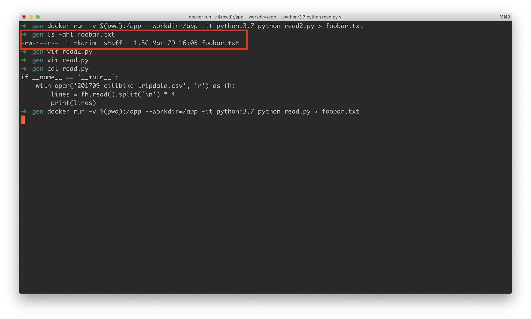

Notice how the foobar.txt file is **1.3G** roughly 4 times the original **300Mb** size of our input file.

Before moving on, let’s just revisit our two code blocks and visit line-by-line what the scripts are doing:

**read.py --** inefficient, non generator leveraging solution

|  |
| --- |
| **if** __name__ == '__main__':  # open a file in read-only mode  # "with" is a special construct that we call the   # context manager - it allows us to define cleanup steps  # when the code "exits" the block from the "with"  **with** open('201709-citibike-tripdata.csv', 'r') **as** fh:  # fh is a file object that represents our file  # by "object" we mean that it is an instance of  # the file class  # here we read the ENTIRE file and then try to  # split it by newline char. Then, we "multiply"  # the resultant list of lines by 4, quadrupling  # our content  lines = fh.read().split('\n') * 4  print(lines) |

**read2.py --** more efficient, generator leveraging solution

|  |
| --- |
| **if** __name__ == '__main__':  **with** open('201709-citibike-tripdata.csv', 'r') **as** fh:  # the file class is special in that it exposes the   # ability to be used as an iterator. In this case  # "fh", our file object can be used as a lazy iterator  # running line by line of the file content if used  # with a for loop. As a result, we don't need to load  # the ENTIRE 300+Mb content at once, allowing us to  # process all the content and in fact write MORE.  **for** line **in** fh:  print(line * 4) |

Before moving on, let’s solve one last problem and along the way see how lazy iterators can be created for our own custom purposes. For this example, let’s generate a very large file with python. This approach is the “slow” way in that we will not attempt to create any lazy iterator solutions and instead just try to build a giant list that we write into our file all at once.

|  |
| --- |
| **import** sys **import** time  **def** **lines_as_list**(num_lines, num_cols):  lines = []  cols = []  # generate column headers  **for** c **in** range(num_cols):  cols.append(f"column_{c}")  # because this is a CSV file, we  # want rows of strings joined by  # ","s  lines.append(",".join(cols))  # for all the lines we need to  # generate, do the same as above  # but with "0" to save time  **for** i **in** range(num_lines):  # this is the SLOW way, so we create  # a VERY large list in memory  lines.append(",".join(["0"]*num_cols))  # return this very large list and try  # to write to file  **return** lines  **if** __name__ == '__main__':  # grab command line args  args = sys.argv[1:]  # what to name our file  name = args[0]  # how many lines  num_lines = int(args[1])  # how many columns  num_cols = int(args[2])  # open a file  **with** open(name, 'w') **as** fh:  # let's time this dude  s0 = time.time()  # grab the very large list, join by  # new lines and write to our file  # all at once  fh.write("\n".join(lines_as_list(num_lines, num_cols)))  print(time.time()-s0) |

Attempting to run this code, we get the following:

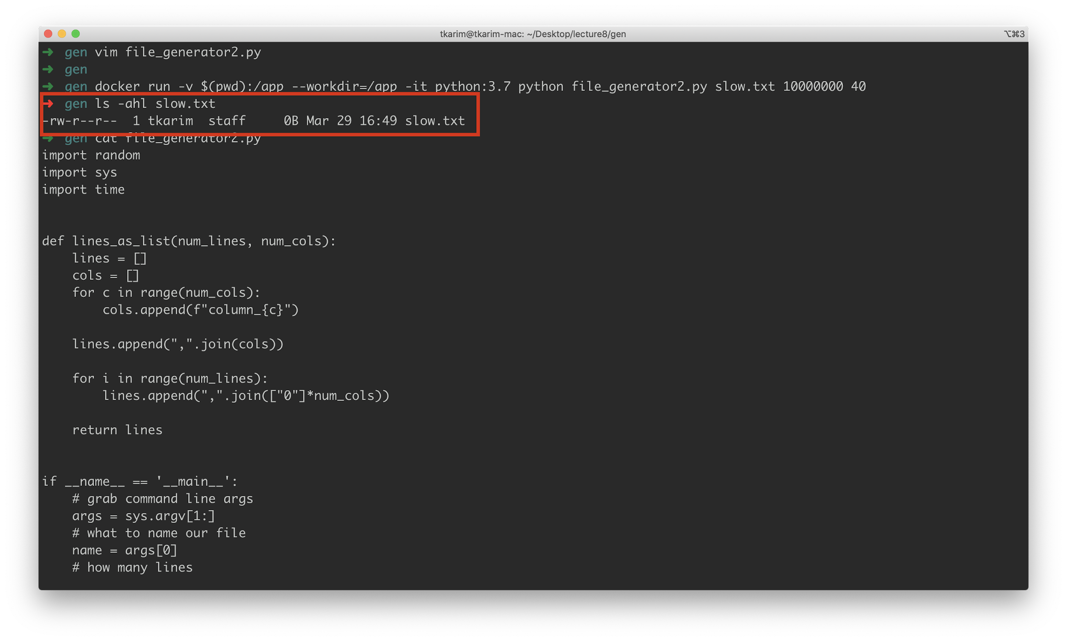

Just like before - we have run out of memory! However, with a few sensible changes, we will be able to process this entire “large file” action in under a minute.

|  |
| --- |
| **import** sys **import** time   **def** **lines_generator**(num_lines, num_cols):  cols = []  **for** c **in** range(num_cols):  cols.append(f"column_{c}")  # the "yield" keyword is how we   # define our "own" generators.  # basically it "returns" this  # line to the code that calls   # lines_generator but DOES NOT  # exit the function  **yield** ",".join(cols)   **for** i **in** range(num_lines):  # once all the yields are completed  # then function exists  **yield** ",".join(["a"]*num_cols)   **if** __name__ == '__main__':  args = sys.argv[1:]  name = args[0]  num_lines = int(args[1])  num_cols = int(args[2])   **with** open(name, 'w') **as** fh:  s0 = time.time()  # this for loop "activates" our generator  **for** line **in** lines_generator(num_lines, num_cols):  fh.write(line+"\n")  print(time.time()-s0) |

Running this code gives us:

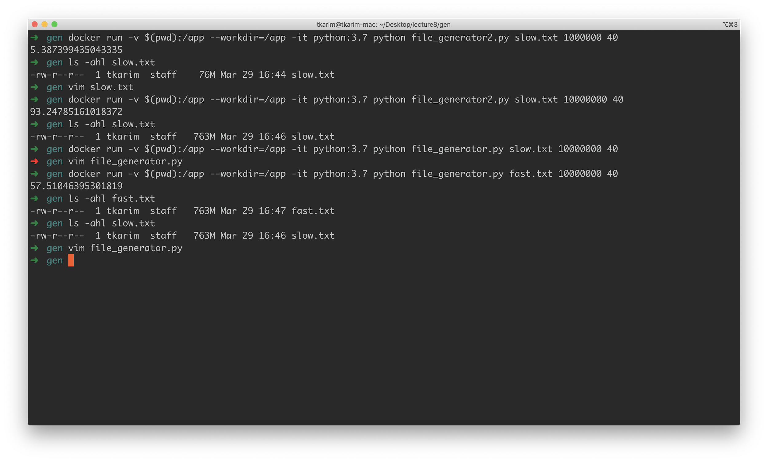

Notice how this entire thing ran in under a minute! Only with minimal code changes.

Generally, the **yield** statement can be used anywhere we’d like, in any way we’d like. For instance, the following:

|  |
| --- |
| **def** **simple**():  **yield** 1  **yield** 2  **yield** 3  **for** k **in** simple():  print(k) |

Will simply “iterate” over **simple** three times.

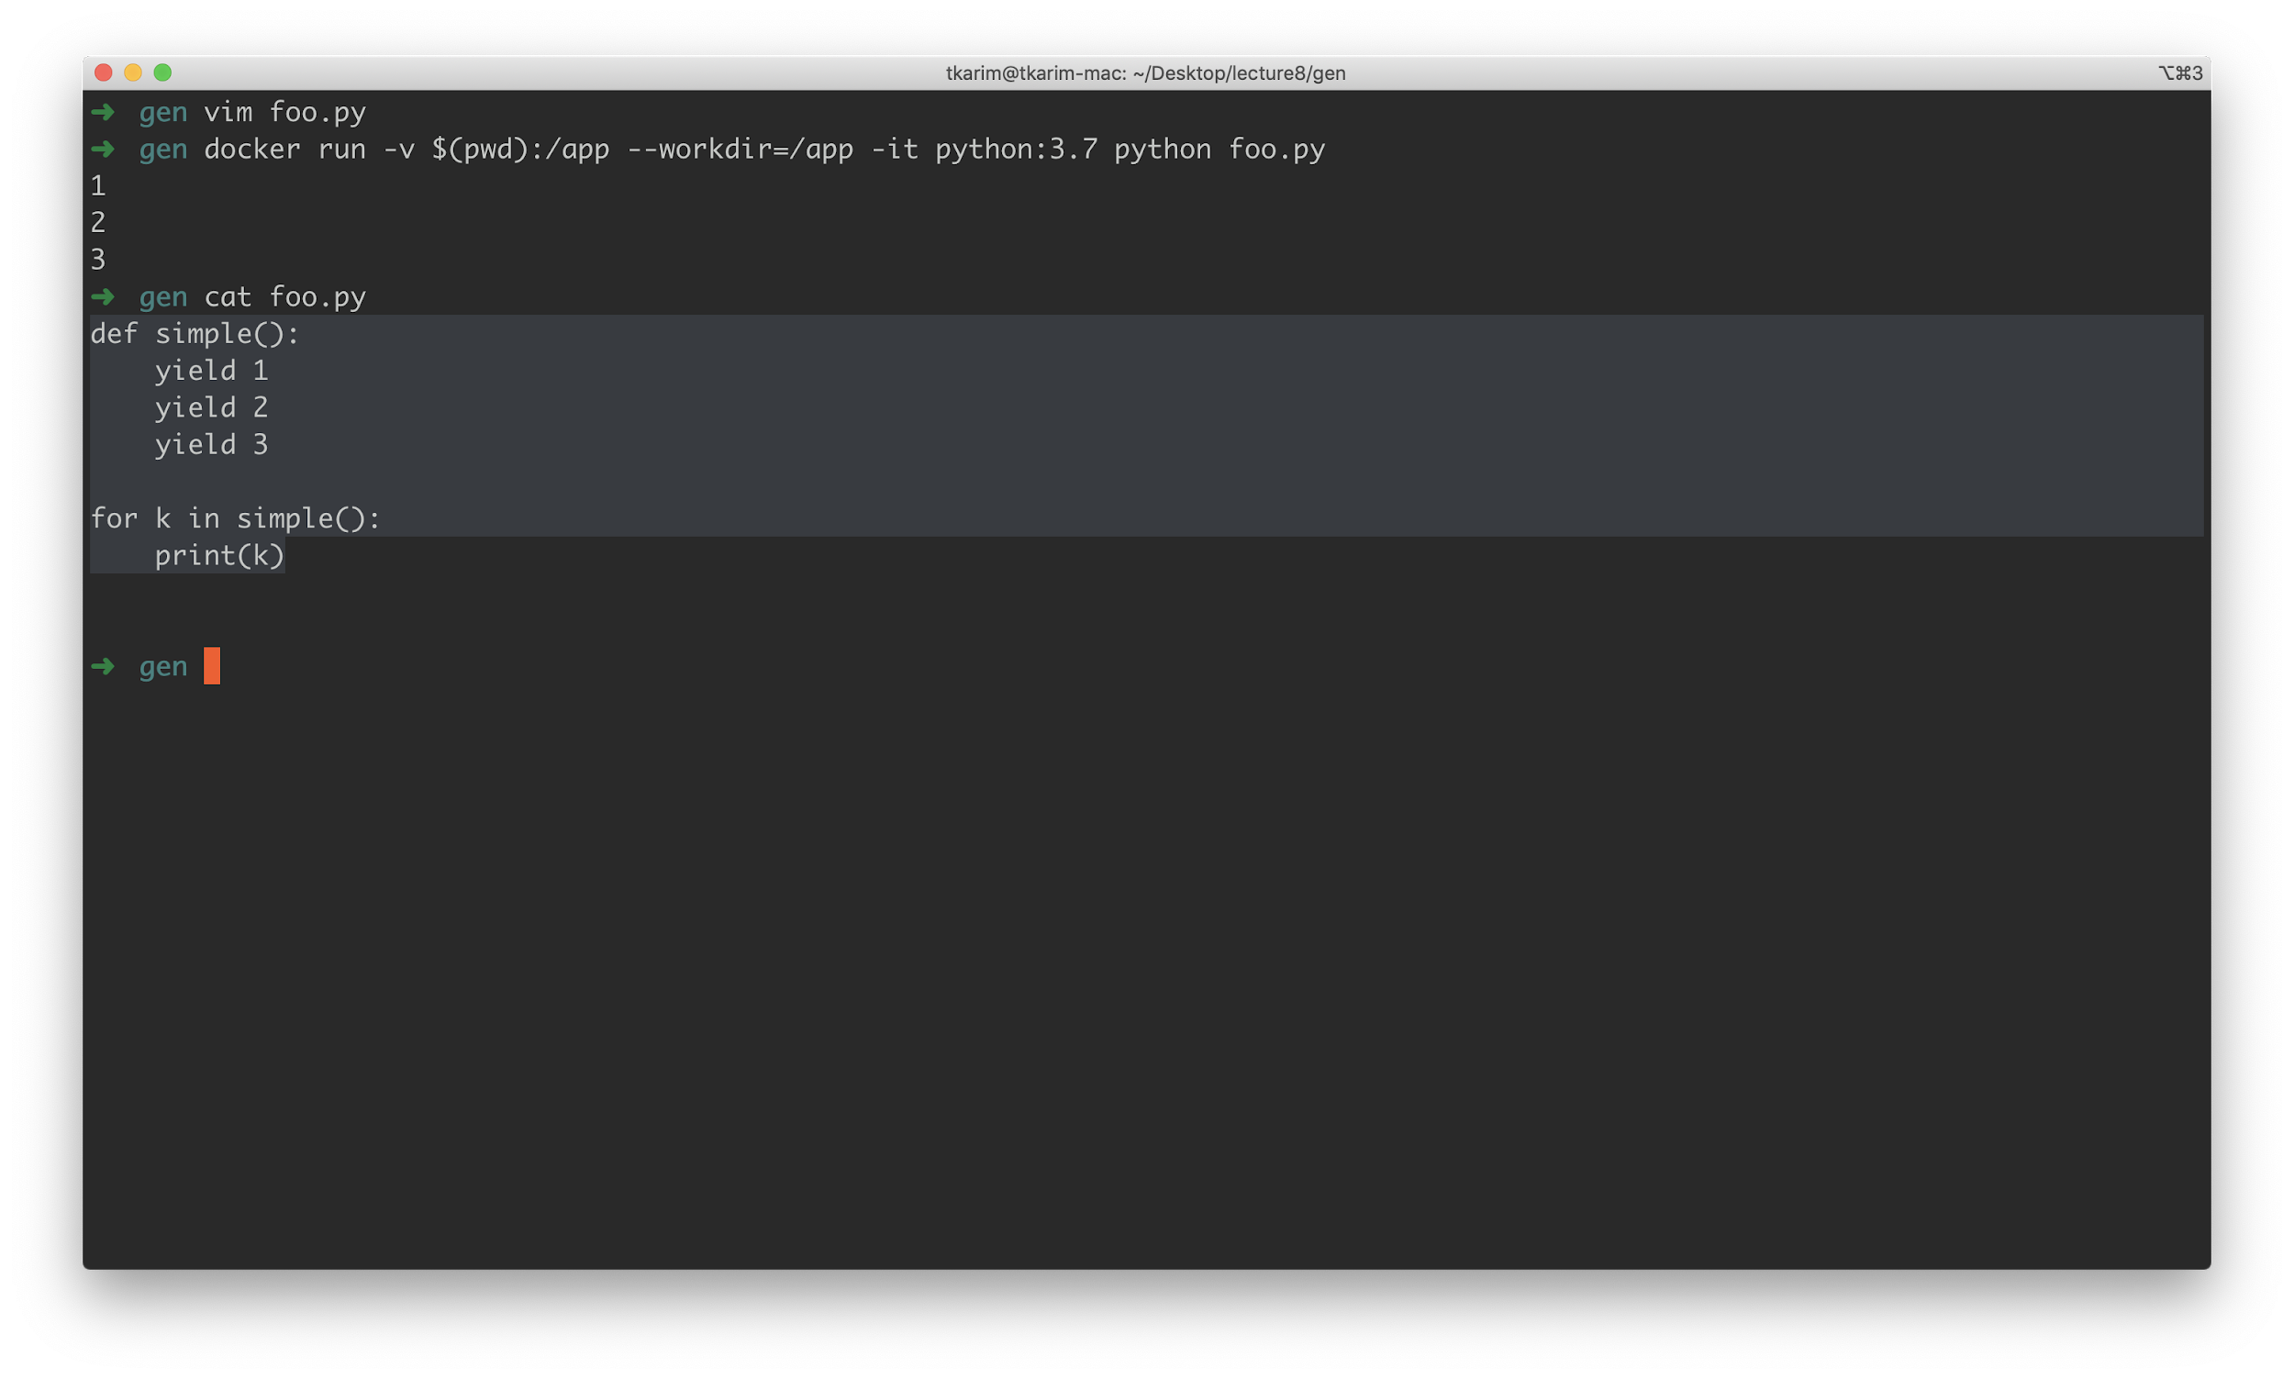

If you can imagine, we can also create “infinite” generators as well, like so:

|  |
| --- |
| **def** **infinite**():  i = 0  **while** **True**:  i += 1  **yield** i  **for** i **in** infinite():  print(i)  **if** i > 15:  print('STOPPING: will not stop otherwise')  **break** |

This is an infinite loop as a generator. Output:

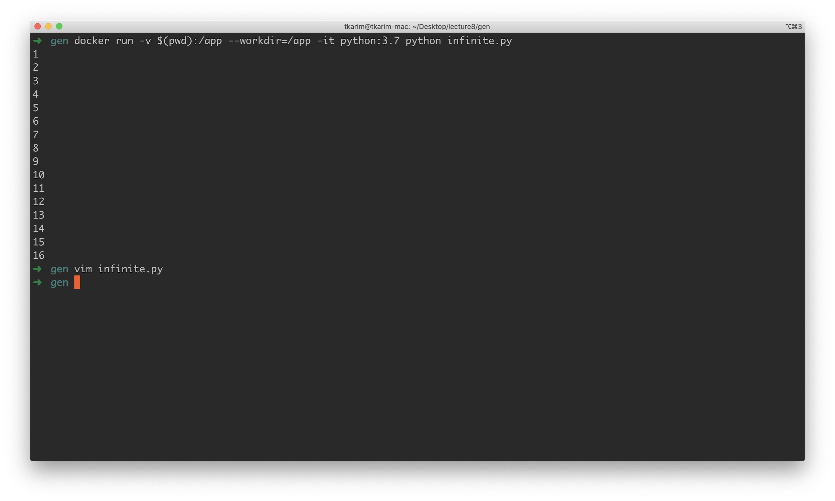

The final note: the **next()** function can be called to access the “next” item in a generator:

|  |
| --- |
| **from** time **import** sleep  **def** **infinite**():  i = 0  **while** **True**:  i += 1  **yield** i  # this will run forever! iterable = infinite() **while** **True**:  print(next(iterable))  sleep(1) # sleeping so it doesn't spit out 100s very quickly |

Running this:

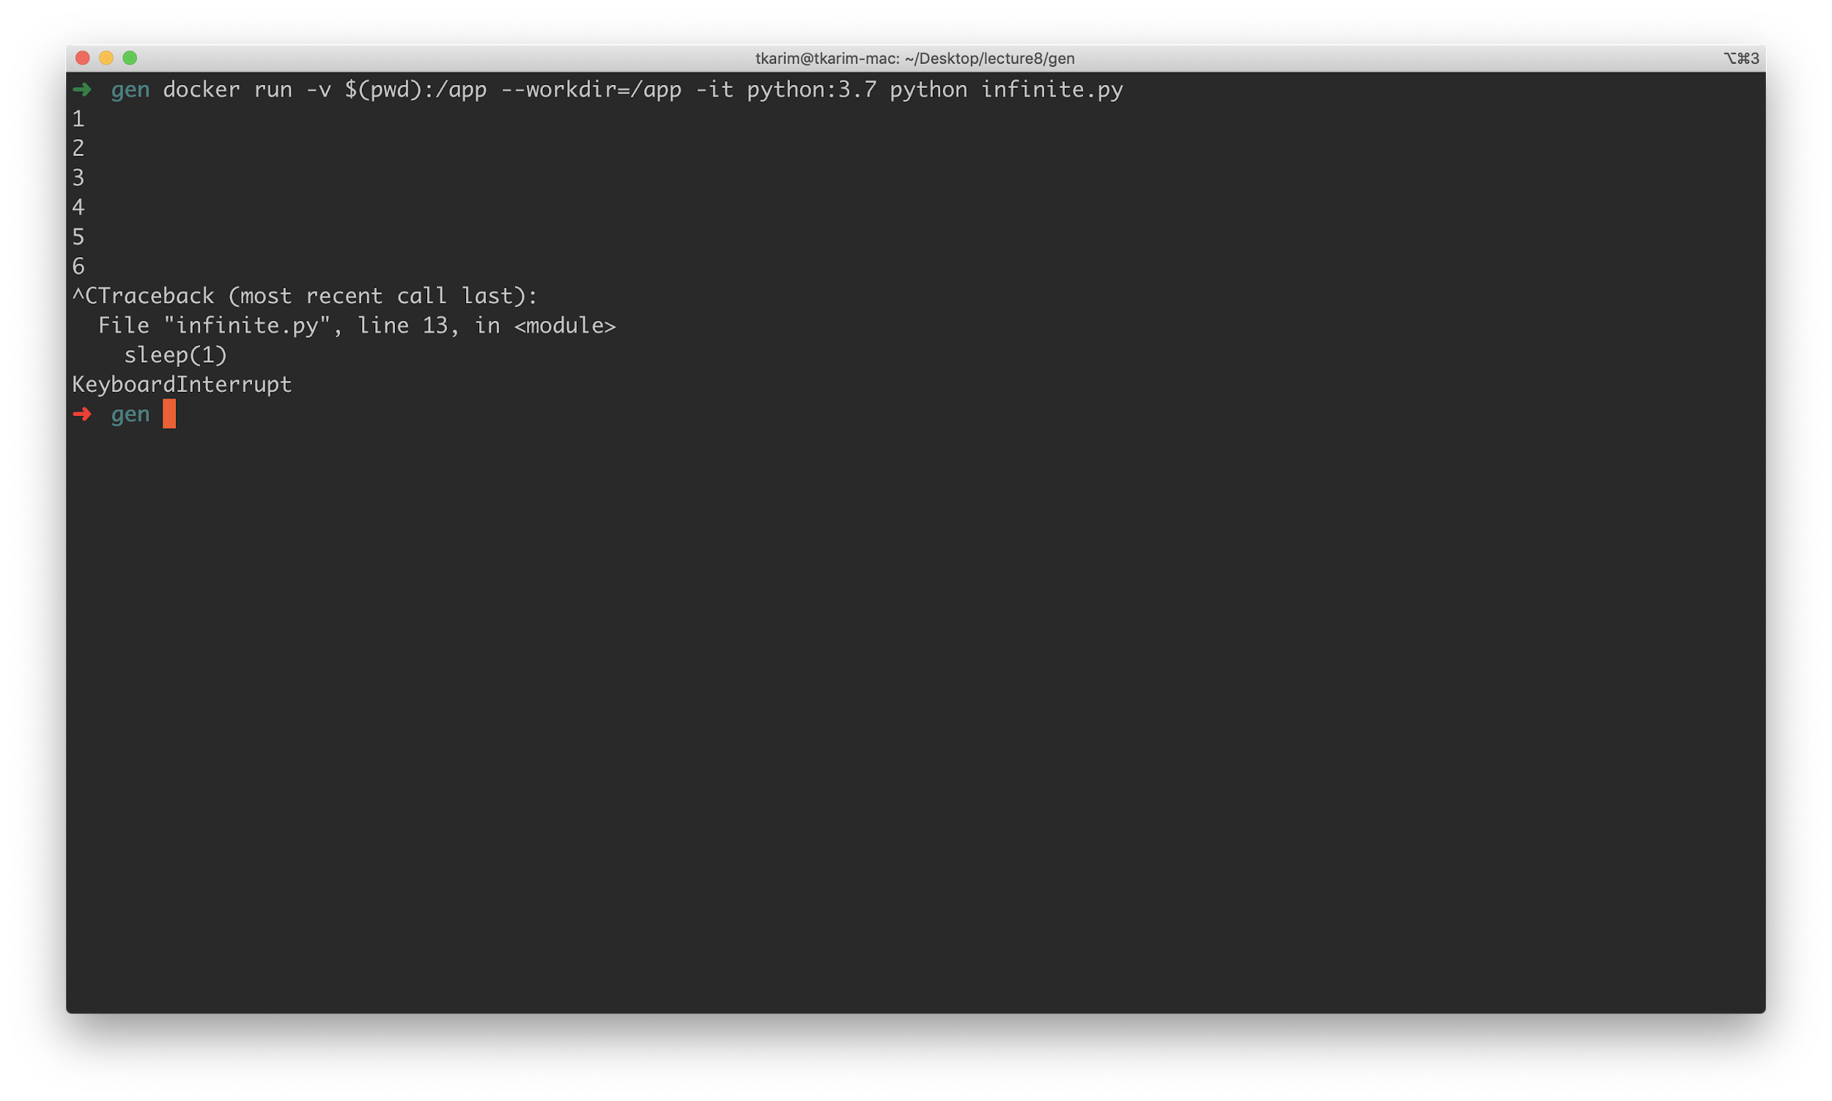

It only stops if we hit **Ctrl+C** invoking a **KeyboardInterrupt**. And lastly, if we do have a finite iterable, like so:

|  |
| --- |
| **from** time **import** sleep  **def** **finite**(n):  i = 0  **while** i < n:  i += 1  **yield** i  # this will run forever! iterable = finite(5) **while** **True**:  print(next(iterable))  sleep(1) |

What happens? The code raises a **StopIteration** exception, which a for loop naturally handles. To handle “by hand” simply except **StopIteration** and in this case, break:

|  |
| --- |
| **from** time **import** sleep  **def** **finite**(n):  i = 0  **while** i < n:  i += 1  **yield** i  # this will run forever! iterable = finite(5) **while** **True**:  **try**:  print(next(iterable))  sleep(1)  **except** StopIteration:  **break** |

And there we have it. There are other features of generators worth discussing but perhaps not for this lecture. In general, generators are very useful and widely adopted natively in python for managing **streams** of data, such as tweets that are read / delivered in real time. Additionally, large files can be read in “chunks” as a stream and operated over with generators to conserve memory. The pattern of “read a chunk”, “apply a transform”, “write somewhere else” works well here.

# Concurrency

Concurrency is the act of running multiple “commands” in our code at the same time. Generally, python is a “blocking” language by default. This means that each line written will execute in order from line 0 to line N. If line K, somewhere between 0 and N happens to take 5 hours, then so be it - the rest of the code will block until that line is completed.

Generally, this is fine and honestly preferred as it makes code much easier to read and understand. However, sometimes this blocking manner can lead to real inefficiencies. Think back to our Project 1, where we were attempting to download a very large number of rows by making multiple API calls. Each API call was blocking! Meaning that we had to wait for page 1 to finish loading before we could access page 2 and so on. This use case is a prime example for concurrency as we really don’t need to wait for page 1 in order to write page 2 and so on.

Let’s begin by first pulling in our [**repo**](https://github.com/mottaquikarim/STA9760_Project1_Part1). Then, we will simplify our **main.py** to make this example a bit easier to understand:

|  |
| --- |
| **import** os **from** math **import** ceil **from** sodapy **import** Socrata  DATA_URL = "data.cityofnewyork.us" DATA_ID = "nc67-uf89"   **if** __name__ == '__main__':  client = Socrata(DATA_URL, os.environ['APP_TOKEN'])  results = client.get(DATA_ID, select='COUNT(*)')  total = int(results[0]['COUNT'])  page_size = 1000  #num_pages = ceil(total / page_size)  num_pages = 10   i = 0  **while** i < num_pages:  print(f"page {i}")  resp = client.get(DATA_ID, limit=page_size, offset=i*page_size)   i += 1  **with** open('output.txt', 'a+') **as** fh:  **for** item **in** resp:  fh.write(f"{str(item)}\n") |

In this simplified version of the code, we got rid of all the args, condensed the code to run within our **if __name__==”__main__”** block and for now, **hardcoded** **num_pages** to **10**.

Let’s build our docker container!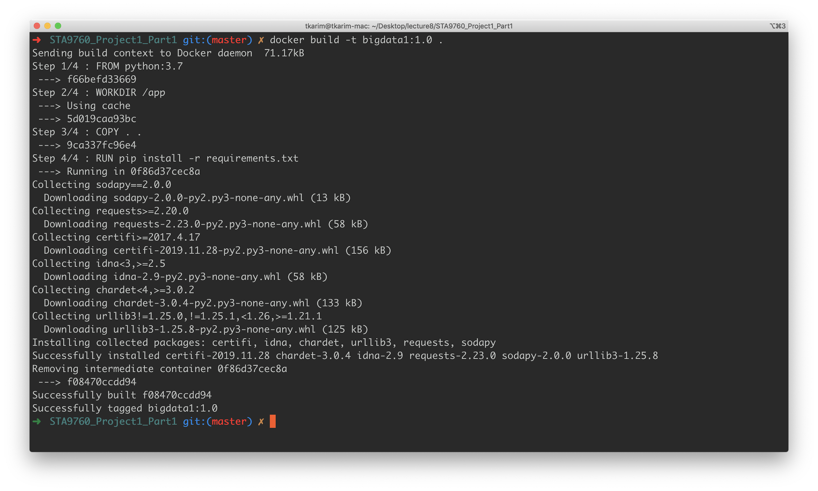

And then run:

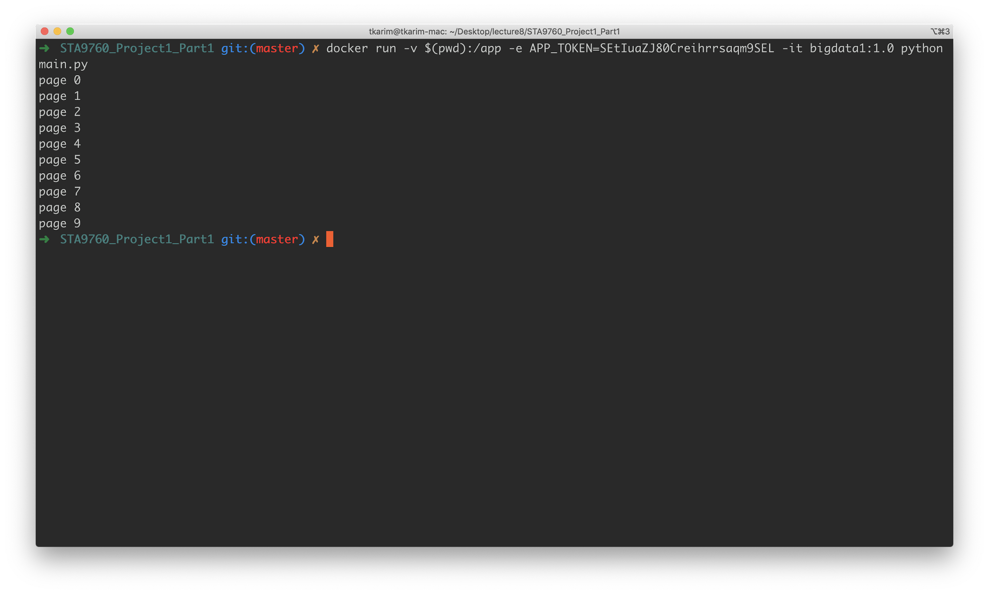

As you can see, we managed to download our first 10 pages, fairly quickly and easily. (It is worth mentioning that the entire dataset consists of ~4000 pages, each page containing 1000 records). For now, let’s try to optimize this particular usecase since it is much simpler. Let’s start by timing our API calls:

|  |
| --- |
| **import** os  **from** math **import** ceil **from** sodapy **import** Socrata **from** time **import** time # import the time library  DATA_URL = "data.cityofnewyork.us" DATA_ID = "nc67-uf89"   **if** __name__ == '__main__':  client = Socrata(DATA_URL, os.environ['APP_TOKEN'])  results = client.get(DATA_ID, select='COUNT(*)')  total = int(results[0]['COUNT'])  page_size = 1000  num_pages = 10  # record the "start time"  s0 = time()  i = 0  **while** i < num_pages:  # this records the "start" time for each  # API call to get a new page  s1 = time()  print(f"page {i}")  resp = client.get(DATA_ID, limit=page_size, offset=i*page_size)  # client.get is blocking, so once we clear  # the get(...) line, we are done waiting on  # the API, so print time difference  print(f"API CALL TIME: {time()-s1}")  # ^^^ note that the f"" string just lets us  # be lazy and encode a bit of python inside  # the string   i += 1  **with** open('output.txt', 'a+') **as** fh:  **for** item **in** resp:  fh.write(f"{str(item)}\n")  # here, subtract time now from s0 which was time   # recorded when we started this script  print(f"DONE {time()-s0}" |
|  |

Notice the additions of the **time()** functions which we wrap around the entire **while** loop and then also around each individual API call. The output of this isn’t all that dramatic:

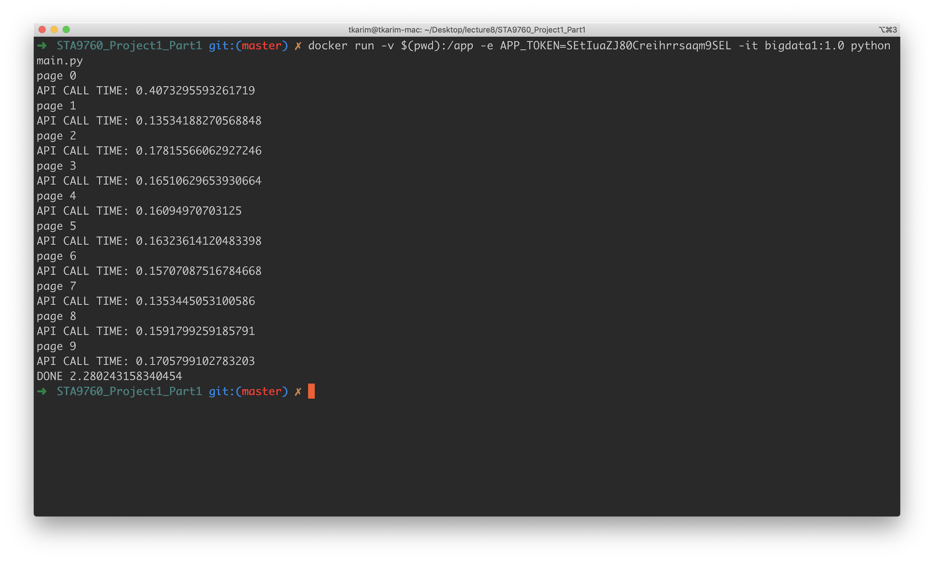

Fetching 10 pages seems to take about **2s**. Not bad! Now, let’s speed this up. The main idea here is that the code just waits between asking the API for page 1 and the time the API responds back with the data requested. It does this again for page 2, 3, and so on. Something kinda like this:

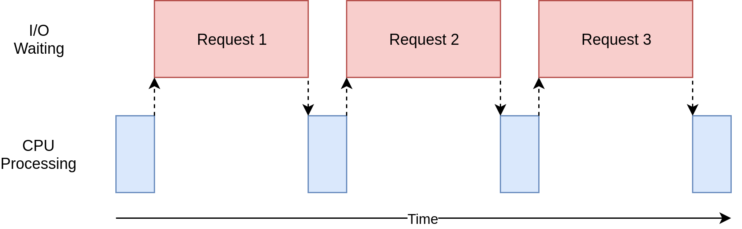

The blue represents actual work the code does vs the red, which is us waiting for the “work” to complete. Mind you for this use case, our code really truly just **waits** as there is nothing to do until the external service (the Socrata API) returns with data. We call this type of application **I/O bound** because we are constrained by the efficiency of an input/output task (asking for / getting back data).

In python, there is a concept called **threading** that helps us efficiently utilize our resources for I/O bound tasks. Conceptually, here is how threading solves the problem above:

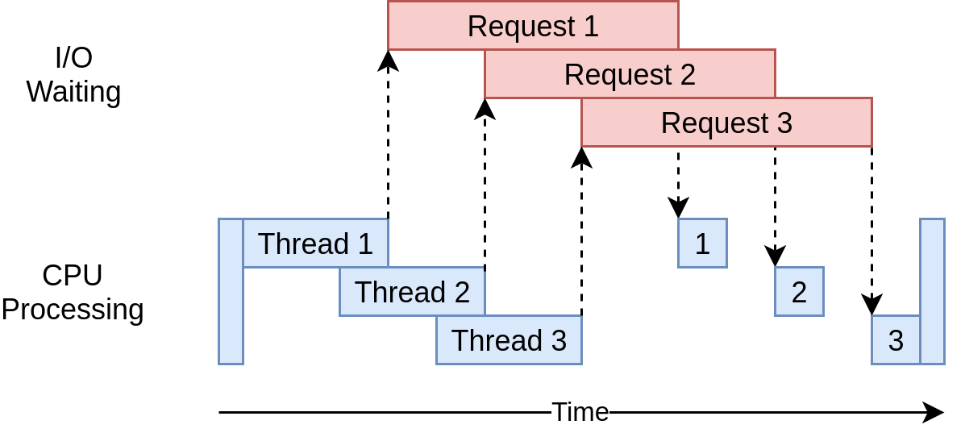

Note how here we are **minimizing** time spent waiting for Request 1 to respond by firing off **Thread 2** immediately. To best understand this, let’s look at a simple example:

|  |
| --- |
| **import** threading **from** time **import** sleep, time  tglobal = time()  **def** **wait**(n, id_):  print(f"""  FUNCTION {id_}, called at: t={int(time()-tglobal)}  SLEEPING FOR: {n}s""")  sleep(n)  **if** __name__=="__main__":  print('threading')  s0 = time()  t1 = threading.Thread(target=wait, args=(2,"A"))  t2 = threading.Thread(target=wait, args=(1,"B"))  t1.start()  t2.start()  t1.join()  t2.join()  print(f"{time()-s0}")   print('normal')  s1 = time()  wait(1, "C")  wait(2, "D")  print(f"{time()-s1}") |

Let’s break this code out into parts:

|  |
| --- |
| **def** **wait**(n, id_):  print(f"""  FUNCTION {id_}, called at: t={int(time()-tglobal)}  SLEEPING FOR: {n}s""")  sleep(n) |

This is a simple function that just “sleeps” for n seconds, similar in principle to an API call except that an API call ideally returns some data or performs some action (which this does not).

The more interesting portion is the next section:

|  |
| --- |
| **import** threading  # ...   **if** __name__=="__main__":  print('threading')  s0 = time()  t1 = threading.Thread(target=wait, args=(2,"A"))  t2 = threading.Thread(target=wait, args=(1,"B"))  t1.start()  t2.start()  t1.join()  t2.join()  print(f"{time()-s0}") |

Here, we are starting two “threads” that invoke the **wait** function we defined above. The **target** keyword argument points to the function each thread should call and the **args** keyword argument takes a **tuple** of arguments that the **wait** function expects, in this case a number (amount of seconds to wait and an **id_** for us to better identify which function is which in our print statements.

To start a thread, we run **thread.start()** and **thread.join()** “pauses” (or in other words, blocks) the rest of the code and waits for our threads to “complete” and exit before moving on.

In this example, we create two **wait** function invocations, one that runs for 1s and one that runs for 2s. Since we are running both within threads, we expect this block to take **2s** in total as they are both starting simultaneous(ish)ly and therefore total time should be the time it takes for the longest function to exit.

In the final block to the code, we invoke two functions “normally” to contrast between the threaded example and the unthreaded example.

|  |
| --- |
| **if** __name__=="__main__":  # .. threading code ..  print('normal')  s1 = time()  wait(1, "C")  wait(2, "D")  print(f"{time()-s1}") |

Ok, let’s run it!

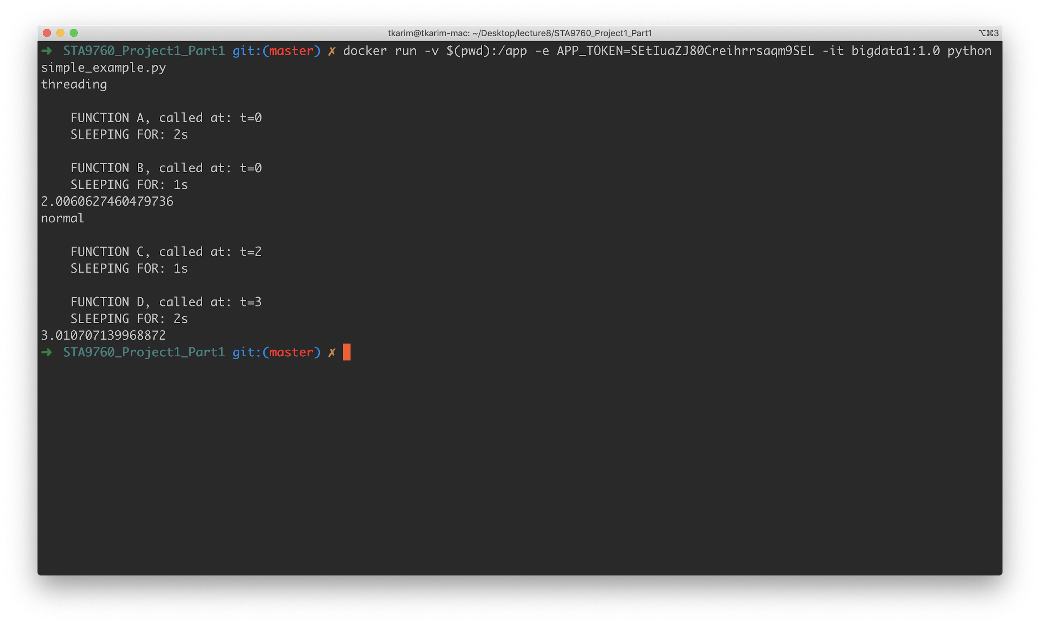

FYI, we are hijacking the docker-run command to run this simpler example:

**docker run -v $(pwd):/app -e APP_TOKEN=API_KEY -it bigdata1:1.0 python simple_example.py**

As you can see, the functions with **ID** A and B both start at time **t=0**, proving that they start at the “same time”. However functions with **ID** C and D start one second after the other since they are blocking and function **D** does not actually start until function **C** has completed. Also notice that the first batch takes only **2s** to complete as we are running concurrently. However, the second batch takes **3s** to complete as function **C** waits for **1s** and function **D** waits for **2s**.

(Heads up, there is a newer interface that manages threading for us, called ThreadPoolExecutor, which I am ignoring in this tutorial as it is slightly more complex to grok. Check out a basic tutorial [**here**](http://masnun.com/2016/03/29/python-a-quick-introduction-to-the-concurrent-futures-module.html)**.** Also, I have not spoken at all about processes, which is a “true” parallelism implementation in python that takes advantage of the numerous cores a machine may have. Again, this is mainly for simplicity and because most of our complexity comes from I/O challenges as we distribute compute with MapReduce, etc. Feel free to read up on it on your own though if you are inclined!). And so finally, let us apply our new threading skills to our original problem:

|  |
| --- |
| **import** os **import** threading  **from** math **import** ceil **from** sodapy **import** Socrata **from** time **import** time  DATA_URL = "data.cityofnewyork.us" DATA_ID = "nc67-uf89"   **def** **call_api**(id_, page_size, offset):  s1 = time()  resp = client.get(id_, limit=page_size, offset=offset)  print(f"API CALL TIME: {time()-s1}")   **with** open('output.txt', 'a+') **as** fh:  **for** item **in** resp:  fh.write(f"{str(item)}\n")   **if** __name__ == '__main__':  client = Socrata(DATA_URL, os.environ['APP_TOKEN'])  results = client.get(DATA_ID, select='COUNT(*)')  total = int(results[0]['COUNT'])  page_size = 1000  # num_pages = ceil(total / page_size)  num_pages = 10   s0 = time()  threads = []  **for** i **in** range(num_pages):  t = threading.Thread(  target=call_api,  args=(DATA_ID, page_size, i*page_size, ),  )  threads.append(t)  t.start()   # wait for all to finish  **for** th **in** threads:  th.join()   print(f"DONE {time()-s0}") |

Let’s break this down! Firstly, we refactor the code API call code into a separate function. This function does not care about anything except that it must make an API call. (Heads up, this is why it is good to wrap functionality into functions - easier to parallelize if needed in future).

|  |
| --- |
| **def** **call_api**(id_, page_size, offset):  s1 = time()  resp = client.get(id_, limit=page_size, offset=offset)  print(f"API CALL TIME: {time()-s1}")   **with** open('output.txt', 'a+') **as** fh:  **for** item **in** resp:  fh.write(f"{str(item)}\n") |

Now, our threading code is ready to invoke this as needed:

|  |
| --- |
| **if** __name__ == '__main__':  client = Socrata(DATA_URL, os.environ['APP_TOKEN'])  results = client.get(DATA_ID, select='COUNT(*)')  total = int(results[0]['COUNT'])  page_size = 1000  # num_pages = ceil(total / page_size)  num_pages = 10   s0 = time()  threads = []  **for** i **in** range(num_pages):  t = threading.Thread(  target=call_api,  args=(DATA_ID, page_size, i*page_size, ),  )  threads.append(t)  t.start()   # wait for all to finish  **for** th **in** threads:  th.join()   print(f"DONE {time()-s0}") |

Note that here, we make a **client** call first - *without threading* - this is because if we were running this “for real”, we would need to know the entire number of rows in order to determine page size. Also, we kind of cheated here by setting the number of threads to 10 - because we are only loading 10 pages. If we were loading all 4000+, it would not make sense to create 4000+ threads as the processor would not be able to handle *all* 4000 at once, rendering performance back to the “non threaded” version, effectively.

Ideally we want to choose a sane number of threads (5 is reasonable) and continue to feed “jobs” to these threads until we are done with the work needed. This is where the **concurrent.futures** interface comes into play as it allows for functionality to do this “behind the scenes” without us having to worry about the logic of bucketing jobs to threads. (To be clear, by “jobs” here I mean function invocations).

At any rate, let’s example the following block of code:

|  |
| --- |
| threads = []  **for** i **in** range(num_pages):  t = threading.Thread(  target=call_api,  args=(DATA_ID, page_size, i*page_size, ),  )  threads.append(t)  t.start()   # wait for all to finish  **for** th **in** threads:  th.join() |

Here, we create an empty list which we populate with threads as we “start” new jobs. Then, we immediately walk through this list and “join” the threads - which, as you may recall, blocks the code until that particular thread is completed. Essentially, we are saying: “don’t run any more code until all threads have completed”. Now, let’s see the performance gains achieved with this approach:

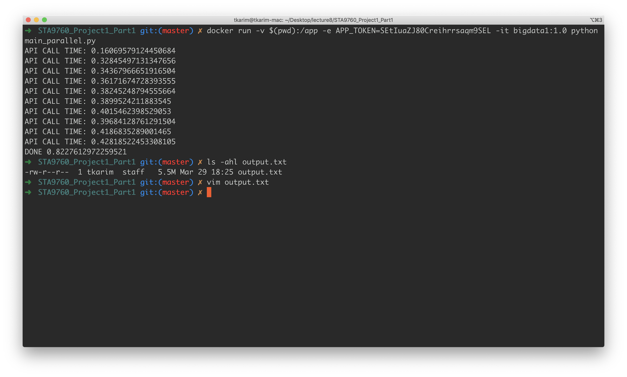

Now THAT’s a performance boost! From ~2.2s to ~0.8 seconds, or a performance boost of over 60%!



Notice that we *still* wrote 5.5M of data regardless. And on that note (final note): in this implementation, we are not guaranteeing that the rows appended are all in order - that is, it is highly probable that results from page 5 were written **before** results from page 2, etc. In order to assert order with the rows that are written, we would likely return all the **resp** objects and iterate them through *after* the blocking, API responses portion is completed in thread. However, using our **threading** interface this gets a bit hairy (it isn’t very easy to return data from a thread). However, again, using the newer **concurrent.futures** interface, this use case becomes a bit easier. (I’ll leave that as an individual exercise).

[**Github Repo**](https://github.com/mottaquikarim/STA9760_Project1_Parallel)